

SFWRENG 3K04 – Software Development

PACEMAKER SIMULINK

Sunday November 29, 2020

TA: Sayed Ahmed

**Lab 1 Group 8**

Muntakim Ali – 400210016

Theodor Aoki – 400202020

Sameer Marok –400201508

Boris Samardzic –400204693

Gurkaran Sondhi –400193807

Table of Contents

2 Introduction 3

3 All Variables 3

3.1 Measured 3

3.2 Parameters 3

3.3 Controlled 4

3.4 Internal 5

4 Modules 6

4.1 Pacemaker Modes 6

**4.1.1** **AOO/VOO/AOOR/VOOR** 6

**4.1.2** **AAI/VVI/AAIR/VVIR** 7

**4.1.3** **DOO/DOOR** 8

**4.1.4** **PARAMETER SELECTION** 9

4.2 Rate Adaptivity 10

4.2.1 Description 10

4.2.2 Variables 10

4.2.3 Requirements 11

4.2.4 Anticipated Changes 11

4.3 Hardware Interface 11

**4.3.1** **PACING** 11

**4.3.2** **SENSING** 13

4.3.3 Description 13

4.3.4 Variables 13

4.4 DCM Communication 14

**4.4.1** **In** 14

**4.4.2** **Out** 16

5 Design Decisions 18

5.1 Pacemaker Modes 18

5.1.1 AOO/VOO/AOOR/VOOR 19

5.1.2 AAI/VVI/AAIR/VVIR 19

5.1.3 DOO/DOOR 20

5.2 Rate Adaptivity 21

5.3 Hardware Interface 22

5.3.1 Pacing 22

5.3.2 Sensing 23

5.4 DCM Communication 24

5.4.1 In 24

5.4.2 Out 25

6 Testing 25

6.1 AOO 25

6.2 VOO 26

6.3 AAI 26

6.4 VVI 28

6.5 DOO 30

6.6 AOOR 32

6.7 VOOR 33

6.8 DOOR 34

6.9 AAIR 35

6.10 VVIR 38

# Introduction

The following documentation gives a concise and general description tailored to the end-user, of the Simulink implementation of the SFWRENG 3K04 Pacemaker Project. The aim of this project is to construct a working pacemaker that acts and reacts to its environment accordingly, as a normal pacemaker would. This documentation will solely focus on the 10 implemented pacing/sensing modes (AOO, VOO, VVI, AAI, DOO, AOOR, VOOR, AAIR, VVIR, and DOOR).

To avoid any confusion, pacing refers to depolarization of the atria or ventricles. Sensing refers to detection of chamber signals. The VVI, AAI, VVIR and AAIR modes both provide sensing and pacing of the heart. VVI and VVIR are used for the ventricles, while AAI and AAIR are used for the Atrium. Those four modes act on an inhibited basis, meaning that the pacemaker is deactivated on a certain activity from the corresponding chamber. AOO, VOO, AOOR, VOOR, DOO and DOOR only pace (no sensing) the atrium and/or ventricle.

The AOO, VOO, AAI, VVI and DOO modes all provide pacing independent of the patient’s activity, whereas the AOOR, VOOR, AAIR, VVIR and DOOR modes all use data from the onboard accelerometer to pace at an adaptive rate.

# All Variables

## Measured

|  |  |  |  |
| --- | --- | --- | --- |
| **Name** | **Units/Type** | **Description** | **Range** |
| t | ms | Time since last pulse | – |
| ATR_SIGNAL | double | electrocardiogram measurement of atrial signal | 0 – 1 |
| VENT_SIGNAL | double | electrocardiogram measurement of ventricular signal | 0 – 1 |
| ATR_CMP_DETECT | boolean | Atrial signal voltage higher than threshold | {true, false} |
| VENT_CMP_DETECT | boolean | Ventricular signal voltage higher than threshold | {true, false} |
| accel | double x 3 | Proper acceleration in g of pacemaker in local (x,y,z) | -4 – 4 |
| Rx | uint8 x 17 | UART in buffer | 0 – 255 |
| Status | uint8 | Indicates whether UART buffer is full | {0, 32} |

## Parameters

|  |  |  |  |
| --- | --- | --- | --- |
| **Name** | **Units/Type** | **Description** | **Range** |
| p_mode | – | Pacemaker operational mode | {AOO,VOO,AAI,VVI, DOO, AOOR, VOOR, AAIR, VVIR, DOOR} |
| p_lower_rate_limit | ppm | Lowest allowable heart rate | 30 – 175 ± 8 ms |
| p_av_delay | ms | Delay between paced atrial and ventricular signals | 70 – 300 ms ± 8 ms |
| p_atr_amplitude | V | Amplitude of pulse delivered to atrium | 0 – 5 ± 12% |
| p_vent_amplitude | V | Amplitude of pulse delivered to ventricle | 0 – 5 ± 12% |
| p_atr_sensitivity | V | Minimum voltage over which signal in atrium is classified as a pulse | 0 – 5 ± 2% |
| p_vent_sensitivity | V | Minimum voltage over which signal in ventricle is classified as a pulse | 0 – 5 ± 2% |
| p_atr_pulse_width | ms | Pulse width of atrial pace | 1 – 30 ± 0.2 ms |
| p_vent_pulse_width | ms | Pulse width of ventricular pace | 1 – 30 ± 0.2 ms |
| p_vrp | ms | Ventricular Refractory Period | 150–500 ± 8 ms |
| p_arp | ms | Atrial Refractory Period | 150–500 ± 8 ms |
| p_max_sensor_rate | ppm | Maximum sensor rate indicated by rate adaptivity | 50 – 175 ± 4 ppm |
| p_activity_threshold | – | Minimum activity level for rate adaptivity | {V-Low, Low, Med-Low, Med, Med-High, High, V-high} |
| p_reaction_time | sec | Time required for pacing rate to rise from lower rate limit to max sensor rate | 10 – 50 ± 3 sec |
| p_response_factor | – | Indicates response to activity levels above threshold | {true, false} |
| p_recovery_time | min | Maximum allowable pacing rate decrease | 2­ – 16 ± 30 sec |

## Controlled

|  |  |  |  |
| --- | --- | --- | --- |
| **Name** | **Units/Type** | **Description** | **Range** |
| PACE_CHARGE_CTRL | boolean | PWM connected to primary capacitor | {true, false} |
| ATR_PACE_CTRL | boolean | Atrial ring connected to primary capacitor | {true, false} |
| VENT_PACE_CTRL | boolean | Ventricular ring connected to primary capacitor | {true, false} |
| ATR_GND_CTRL | boolean | Atrial ring connected to ground | {true, false} |
| VENT_GND_CTRL | boolean | Ventricular ring connected to ground | {true, false} |
| PACE_GND_CTRL | boolean | Atrial and Ventricular tip connected to blocking capacitor | {true, false} |
| Z_ATR_CTRL | boolean | Impedance circuit connected to atrial ring | {true, false} |
| Z_VENT_CTRL | boolean | Impedance circuit connected to ventricular ring | {true, false} |
| PACING_REF_PWM | % | Reference PWM for primary capacitor | 0–100 |
| ATR_CMP_REF_PWM | % | Reference PWM for atrial signal comparator | 0–100 |
| VENT_CMP_REF_PWM | % | Reference PWM for ventricular signal comparator | 0–100 |
| FRONTEND_CTRL | boolean | Sensing circuit connected to leads | {true, false} |
| Tx | uint8 x 16 | UART out buffer | 0 – 255 |

## Internal

|  |  |  |  |
| --- | --- | --- | --- |
| **Name** | **Units/Type** | **Description** | **Range** |
| h_atr_pulse_detected | boolean | Pulse detected in atrium | {true, false} |
| h_vent_pulse_detected | boolean | Pulse detected in ventricle | {true, false} |
| XOO_pace_start | boolean | AOO or VOO indicates pace | {true, false} |
| XXI_pace_start | boolean | AAI or VVI indicates pace | {true, false} |
| DOO_A_pace_start | boolean | DOO indicates atrial pace | {true, false} |
| DOO_V_pace_start | boolean | DOO indicates ventricular pace | {true, false} |
| DOO_AV_select | boolean | DOO indicates which chamber will be paced next | {true, false} |
| A_pace_start | boolean | Signal to pace atrium | {true, false} |
| V_pace_start | boolean | Signal to pace ventricle | {true, false} |
| AV_select | boolean | Selects which chamber will be paced next | {A, V} |
| sensor_rate | ppm | Rate adaptivity indicated rate | p_lower_rate_limit – p_max_sensor_rate |
| increase_rate | ppm/sec | Pace rate increase | 0 – 14.5 |
| decrease_rate | ppm/sec | Pace rate decrease | 0 – 1.3 |
| sensor_rate’ | ppm | Sensor rate for modes | p_lower_rate_limit – p_max_sensor_rate |
| increase_rate’ | ppm/sec | Increase rate for modes | 0 – 14.5 |
| decrease_rate’ | ppm/sec | Decrease rate for modes | 0 – 1.3 |
| buffer | double | Last 25 values of accel | -4 – 4 |
| pulse_detected | boolean | General pulse detection | {true, false} |
| refractory_period | ms | General refractory period | 150–500 ± 8 ms |
| current_LRL | ppm | Current pacing rate | 30 – 175 ppm |
| activity_pp | double | Peak to peak of activity signal | 0 – 4 |
| code | uint8 | Last received code from DCM | 0 ­– 5 |

# Modules

## Pacemaker Modes

### **AOO/VOO/AOOR/VOOR**

#### Description

In AOO, VOO, AOOR and VOOR modes one chamber is paced at the indicated rate.

#### Variables

##### Measured

|  |  |  |  |
| --- | --- | --- | --- |
| **Name** | **Units/Type** | **Description** | **Range** |
| t | ms | Time since last pulse | – |

##### Parameters

No parameters

##### Controlled

No controlled variables

##### Internal

|  |  |  |  |
| --- | --- | --- | --- |
| **Name** | **Units/Type** | **Description** | **Range** |
| XOO_pace_start | boolean | AOO or VOO indicates pace | {true, false} |
| sensor_rate’ | ppm | Sensor rate for modes | p_lower_rate_limit – p_max_sensor_rate |
| increase_rate’ | ppm/sec | Increase rate for modes | 0 – 14.5 |
| decrease_rate’ | ppm/sec | Decrease rate for modes | 0 – 1.3 |
| current_LRL | ppm | Current pacing rate | 30 – 175 ppm |

#### Requirements

|  |  |  |  |  |  |  |  |
| --- | --- | --- | --- | --- | --- | --- | --- |
| **Source State** | **Event** | **Condition** | | **Condition Actions** | **Exit Actions** | **Destination State** | **Entry Actions** |
| INITIAL | NONE | NONE | | NONE | NONE | PACE | current_LRL = sensor_rate |
| PACE | NONE | sensor_rate’ > current_LRL | current_LRL + increase_rate’ * t > sensor_rate’ | current_LRL = sensor_rate | NONE | UPDATE_RATE | XOO_pace_start = true |
| current_LRL + increase_rate’ * t ≤ sensor_rate’ | current_LRL += increase_rate’ * t |
| sensor_rate’ ≤ current_LRL | current_LRL – decrease_rate’ * t < sensor_rate’ | current_LRL = sensor_rate |
| current_LRL – decrease_rate’ * t ≥ sensor_rate’ | current_LRL -= decrease_rate’ * t |
| UPDATE_RATE | NONE | after(60/current_LRL, sec) | | NONE | t = elapsed(sec) | PACE | on after(1, msec):  XOO_pace_start = false |

#### Anticipated Changes

AOO/VOO/AOOR/VOOR logic could be combined with AAI/VVI/AAIR/VVIR (4.1.2) logic by using parameter selection (4.1.4) to route false to pulse_detected (4.1.2.2.4) in the latter when in AOO/VOO/AOOR/VOOR modes.

### **AAI/VVI/AAIR/VVIR**

#### Description

In AAI, VVI, AAIR and VVIR modes, one chamber is paced at the indicated rate but inhibited by sensed pulses in the same chamber.

#### Variables

##### Measured

|  |  |  |  |
| --- | --- | --- | --- |
| **Name** | **Units/Type** | **Description** | **Range** |
| t | ms | Time since last pulse | – |

##### Parameters

No parameters

##### Controlled

No controlled variables

##### Internal

|  |  |  |  |
| --- | --- | --- | --- |
| **Name** | **Units/Type** | **Description** | **Range** |
| XXI_pace_start | boolean | AAI or VVI indicates pace | {true, false} |
| sensor_rate’ | ppm | Sensor rate for modes | p_lower_rate_limit – p_max_sensor_rate |
| increase_rate’ | ppm/sec | Increase rate for modes | 0 – 14.5 |
| decrease_rate’ | ppm/sec | Decrease rate for modes | 0 – 1.3 |
| buffer | double | Last 25 values of accel | -4 – 4 |
| pulse_detected | boolean | General pulse detection | {true, false} |
| refractory_period | ms | General refractory period | 150–500 ± 8 ms |
| current_LRL | ppm | Current pacing rate | 30 – 175 ppm |

#### Requirements

|  |  |  |  |  |  |  |  |
| --- | --- | --- | --- | --- | --- | --- | --- |
| **Source State** | **Condition** | | | **Condition Actions** | **Exit Actions** | **Destination State** | **Entry Actions** |
| INITIAL | NONE | | | NONE | NONE | WAIT | current_LRL = sensor_rate |
| WAIT | pulse_detected == 1 | | | NONE | t = elapsed(sec) | SENSE |  |
| after(60/current_LRL – 0.001refractory_period + 0.001,sec) | | | NONE | t = elapsed(sec) | PACE |  |
| PACE | after(p_rp, msec) | sensor_rate’ > current_LRL | current_LRL + increase_rate’ * t > sensor_rate’ | current_LRL = sensor_rate | t += elapsed(sec) | WAIT | XXI_pace_start = true  on after(1, msec)  XXI_pace_start = true |
| current_LRL + increase_rate’ * t ≤ sensor_rate’ | current_LRL += increase_rate’ * t |
| sensor_rate’ ≤ current_LRL | current_LRL – decrease_rate’ * t < sensor_rate’ | current_LRL = sensor_rate |
| current_LRL – decrease_rate’ * t ≥ sensor_rate’ | current_LRL -= decrease_rate’ * t |
| SENSE | NONE |

#### Anticipated Changes

See 4.1.1.4

### **DOO/DOOR**

#### Description

In DOO and DOOR modes, both chambers are paced at the indicated rate, with fixed delay between atrial and ventricular pulses.

#### Variables

##### Measured

|  |  |  |  |
| --- | --- | --- | --- |
| **Name** | **Units/Type** | **Description** | **Range** |
| t | ms | Time since last pulse | – |

##### Parameters

|  |  |  |  |
| --- | --- | --- | --- |
| **Name** | **Units/Type** | **Description** | **Range** |
| p_av_delay | ms | Delay between paced atrial and ventricular signals | 70 – 300 ms ± 8 ms |

##### Controlled

No controlled variables

##### Internal

|  |  |  |  |
| --- | --- | --- | --- |
| **Name** | **Units/Type** | **Description** | **Range** |
| DOO_A_pace_start | boolean | DOO indicates atrial pace | {true, false} |
| DOO_V_pace_start | boolean | DOO indicates ventricular pace | {true, false} |
| DOO_AV_select | boolean | DOO indicates which chamber will be paced next | {true, false} |
| sensor_rate’ | ppm | Sensor rate for modes | p_lower_rate_limit – p_max_sensor_rate |
| increase_rate’ | ppm/sec | Increase rate for modes | 0 – 14.5 |
| decrease_rate’ | ppm/sec | Decrease rate for modes | 0 – 1.3 |
| current_LRL | ppm | Current pacing rate | 30 – 175 ppm |

#### Requirements

|  |  |  |  |  |  |  |  |
| --- | --- | --- | --- | --- | --- | --- | --- |
| **Source State** | **Condition** | | | **Condition Actions** | **Exit Actions** | **Destination State** | **Entry Actions** |
| INITIAL | NONE | | | NONE | NONE | PACE_VENT | current_LRL = sensor_rate |
| PACE_ATR | after(p_av_delay,msec) | sensor_rate’ > current_LRL | current_LRL + increase_rate’ * t > sensor_rate’ | current_LRL = sensor_rate | t += elapsed(sec) | PACE_VENT | DOO_A_pace_start = true  on after(1, msec)  DOO_A_pace_start = true  DOO_AV_select = V |
| current_LRL + increase_rate’ * t ≤ sensor_rate’ | current_LRL += increase_rate’ * t |
| sensor_rate’ ≤ current_LRL | current_LRL – decrease_rate’ * t < sensor_rate’ | current_LRL = sensor_rate |
| current_LRL – decrease_rate’ * t ≥ sensor_rate’ | current_LRL -= decrease_rate’ * t |
| PACE_VENT | after(60/current_LRL – p_av_delay/1000, sec) | | | NONE | t = elapsed(sec) | PACE_ATR | DOO_V_pace_start = true  on after(1, msec)  DOO_V_pace_start = true  DOO_AV_select = A |

#### Anticipated Changes

DOO/DOOR would be the basis for extending to the DXXX modes by adding sensed signal states as appropriate.

### **PARAMETER SELECTION**

#### Description

Parameter selection parses parameter information to feed to the actual mode logic, then routes the mode logic output to the correct signal outputs.

#### Variables

##### Measured

No measured variables

##### Parameters

|  |  |  |  |
| --- | --- | --- | --- |
| **Name** | **Units/Type** | **Description** | **Range** |
| p_mode | – | Pacemaker operational mode | {AOO,VOO,AAI,VVI, DOO, AOOR, VOOR, AAIR, VVIR, DOOR} |
| p_lower_rate_limit | ppm | Lowest allowable heart rate | 30 – 175 ± 8 ms |
| p_av_delay | ms | Delay between paced atrial and ventricular signals | 70 – 300 ms ± 8 ms |
| p_vrp | ms | Ventricular Refractory Period | 150–500 ± 8 ms |
| p_arp | ms | Atrial Refractory Period | 150–500 ± 8 ms |

##### Controlled

No controlled variables

##### Internal

|  |  |  |  |
| --- | --- | --- | --- |
| **Name** | **Units/Type** | **Description** | **Range** |
| h_atr_pulse_detected | boolean | Pulse detected in atrium | {true, false} |
| h_vent_pulse_detected | boolean | Pulse detected in ventricle | {true, false} |
| XOO_pace_start | boolean | AOO or VOO indicates pace | {true, false} |
| XXI_pace_start | boolean | AAI or VVI indicates pace | {true, false} |
| DOO_A_pace_start | boolean | DOO indicates atrial pace | {true, false} |
| DOO_V_pace_start | boolean | DOO indicates ventricular pace | {true, false} |
| DOO_AV_select | boolean | DOO indicates which chamber will be paced next | {true, false} |
| A_pace_start | boolean | Signal to pace atrium | {true, false} |
| V_pace_start | boolean | Signal to pace ventricle | {true, false} |
| AV_select | boolean | Selects which chamber will be paced next | {A, V} |
| sensor_rate | ppm | Rate adaptivity indicated rate | p_lower_rate_limit – p_max_sensor_rate |
| increase_rate | ppm/sec | Pace rate increase | 0 – 14.5 |
| decrease_rate | ppm/sec | Pace rate decrease | 0 – 1.3 |
| sensor_rate’ | ppm | Sensor rate for modes | p_lower_rate_limit – p_max_sensor_rate |
| increase_rate’ | ppm/sec | Increase rate for modes | 0 – 14.5 |
| decrease_rate’ | ppm/sec | Decrease rate for modes | 0 – 1.3 |
| pulse_detected | boolean | General pulse detection | {true, false} |
| refractory_period | ms | General refractory period | 150–500 ± 8 ms |

#### Requirements

|  |  |  |  |  |  |  |  |  |
| --- | --- | --- | --- | --- | --- | --- | --- | --- |
| **mode** | **sensor_rate’** | **increase_rate’** | **decrease_rate’** | **pulse_detected** | **refractory_period** | **A_pace_start** | **V_pace_start** | **AV_select** |
| AOO | p_lower_rate_limit | 0 | 0 | X | X | XOO_pace_start | 0 | A |
| VOO | X | X | 0 | XOO_pace_start | V |
| AAI | h_atr_pulse_detected | p_arp | XXI_pace_start | 0 | A |
| VVI | h_vent_pulse_detected | p_vrp | 0 | XXI_pace_start | V |
| DOO | X | X | DOO_A_pace_start | DOO_V_pace_start | DOO_AV_select |
| AOOR | sensor_rate | increase_rate | decrease_rate | X | X | XOO_pace_start | 0 | A |
| VOOR | X | X | 0 | XOO_pace_start | V |
| AAIR | h_atr_pulse_detected | p_arp | XXI_pace_start | 0 | A |
| VVIR | h_vent_pulse_detected | p_vrp | 0 | XXI_pace_start | V |
| DOOR | X | X | DOO_A_pace_start | DOO_V_pace_start | DOO_AV_select |

#### Anticipated Changes

If more modes were to be implemented, parameter would have to take them into account in order to route the input and output signals correctly.

## Rate Adaptivity

### Description

The rate adaptivity module indicates the rate at which pacing should occur according to the activity as sensed through the on-board accelerometer. It also calculates the rate at which the pacing rate changes as defined by the rate adaptivity parameters.

### Variables

#### Measured

|  |  |  |  |
| --- | --- | --- | --- |
| **Name** | **Units/Type** | **Description** | **Range** |
| accel | double x 3 | Proper acceleration in g of pacemaker in local (x,y,z) | -4 – 4 |

#### Parameters

|  |  |  |  |
| --- | --- | --- | --- |
| **Name** | **Units/Type** | **Description** | **Range** |
| p_lower_rate_limit | ppm | Lowest allowable heart rate | 30 – 175 ± 8 ms |
| p_max_sensor_rate | ppm | Maximum sensor rate indicated by rate adaptivity | 50 – 175 ± 4 ppm |
| p_activity_threshold | – | Minimum activity level for rate adaptivity | {V-Low, Low, Med-Low, Med, Med-High, High, V-high} |
| p_reaction_time | sec | Time required for pacing rate to rise from lower rate limit to max sensor rate | 10 – 50 ± 3 sec |
| p_response_factor | – | Indicates response to activity levels above threshold | {true, false} |
| p_recovery_time | min | Maximum allowable pacing rate decrease | 2­ – 16 ± 30 sec |

#### Controlled

No controlled variables

#### Internal

|  |  |  |  |
| --- | --- | --- | --- |
| **Name** | **Units/Type** | **Description** | **Range** |
| sensor_rate | ppm | Rate adaptivity indicated rate | p_lower_rate_limit – p_max_sensor_rate |
| increase_rate | ppm/sec | Pace rate increase | 0 – 14.5 |
| decrease_rate | ppm/sec | Pace rate decrease | 0 – 1.3 |
| buffer | double | Last 25 values of accel | -4 – 4 |
| activity_pp | double | peak to peak of activity signal | 0 – 4 |

### Requirements

|  |  |
| --- | --- |
| **Variable** | **Value** |
| activity_pp | max(buffer) – min(buffer) |
| increase_rate | (p_max_sensor_rate – p_lower_rate_limit) / p_reaction_time |
| decrease_rate | (p_max_sensor_rate – p_lower_rate_limit) / (60 * p_recovery_time) |
| activity_overdrive | 4 * p_response_factor * (p_activity_pp – p_activity_threshold) |
| sensor_rate | min(p_max_sensor_rate, max(p_lower_rate_limit, activity_overdrive)) |

### Anticipated Changes

Should a different design for rate adaptivity be selected, this module would need reworking to match those requirements.

## Hardware Interface

### **PACING**

#### Description

The pacing module monitors the pace start and AV select lines and controls which level to charge the pacing capacitor at and which chamber to pace.

#### Variables

##### Measured

No measured variables

##### Parameters

|  |  |  |  |
| --- | --- | --- | --- |
| **Name** | **Units/Type** | **Description** | **Range** |
| p_atr_amplitude | V | Amplitude of pulse delivered to atrium | 0 – 5 ± 12% |
| p_vent_amplitude | V | Amplitude of pulse delivered to ventricle | 0 – 5 ± 12% |
| p_atr_pulse_width | ms | Pulse width of atrial pace | 1 – 30 ± 0.2 ms |
| p_vent_pulse_width | ms | Pulse width of ventricular pace | 1 – 30 ± 0.2 ms |

##### Controlled

|  |  |  |  |
| --- | --- | --- | --- |
| **Name** | **Units/Type** | **Description** | **Range** |
| PACE_CHARGE_CTRL | boolean | PWM connected to primary capacitor | {true, false} |
| ATR_PACE_CTRL | boolean | Atrial ring connected to primary capacitor | {true, false} |
| VENT_PACE_CTRL | boolean | Ventricular ring connected to primary capacitor | {true, false} |
| ATR_GND_CTRL | boolean | Atrial ring connected to ground | {true, false} |
| VENT_GND_CTRL | boolean | Ventricular ring connected to ground | {true, false} |
| PACE_GND_CTRL | boolean | Atrial and Ventricular tip connected to blocking capacitor | {true, false} |
| Z_ATR_CTRL | boolean | Impedance circuit connected to atrial ring | {true, false} |
| Z_VENT_CTRL | boolean | Impedance circuit connected to ventricular ring | {true, false} |
| PACING_REF_PWM | % | Reference PWM for primary capacitor | 0–100 |

##### Internal

|  |  |  |  |
| --- | --- | --- | --- |
| **Name** | **Units/Type** | **Description** | **Range** |
| A_pace_start | boolean | Signal to pace atrium | {true, false} |
| V_pace_start | boolean | Signal to pace ventricle | {true, false} |
| AV_select | boolean | Selects which chamber will be paced next | {A, V} |

#### Requirements

|  |  |  |  |  |  |  |
| --- | --- | --- | --- | --- | --- | --- |
| **Source State** | **Event** | **Condition** | **Condition Actions** | **Exit Actions** | **Destination State** | **Entry Actions** |
| INITIAL | NONE | NONE | NONE | NONE | C22_Charge | VENT_GND_CTRL=false  Z_VENT_CTRL=false  Z_ATR_CTRL=false  ATR_GND_CTRL=false |
| C22_Charge | NONE | V_pace_start == false AND  A_pace_start == false | NONE | NONE | Buffer | VENT_PACE_CTRL=false  ATR_PACE_CTRL=false  PACE_CHARGE_CTRL=true  PACE_GND_CTRL=true |
| Buffer | NONE | A_pace_start == true | NONE | NONE | A_pacing | NONE |
| V_pace_start == true | NONE | NONE | V_pacing | NONE |
| A_pacing | NONE | after(p_atr_pulse_width) | NONE | NONE | C21_Discharge_A | PACE_CHARGE_CTRL=false  VENT_PACE_CTRL=false  VENT_GND_CTRL=false  ATR_GND_CTRL=false  ATR_PACE_CTRL=true |
| C21_Discharge_A | NONE | NONE | NONE | NONE | C22_Charge | ATR_PACE_CTRL=false  ATR_GND_CTRL=true |
| V_pacing | NONE | after(p_vent_pulse_width) | NONE | NONE | C21_Discharge | PACE_CHARGE_CTRL=false  ATR_PACE_CTRL=false  ATR_GND_CTRL=false  VENT_GND_CTRL=false  VENT_PACE_CTRL=true |
| C21_Discharge_V | NONE | NONE | NONE | NONE | C22_Charge | VENT_PACE_CTRL=false;  VENT_GND_CTRL=true; |

#### Anticipated Changes

A change in hardware would necessitate reconfiguring the output signals to match the new hardware.

### **SENSING**

### Description

The sensing module sets the levels of the reference capacitors and parses the signal to output pulses when natural heart pulses are detected.

### Variables

##### Measured

|  |  |  |  |
| --- | --- | --- | --- |
| **Name** | **Units/Type** | **Description** | **Range** |
| ATR_CMP_DETECT | boolean | Atrial signal voltage higher than threshold | {true, false} |
| VENT_CMP_DETECT | boolean | Ventricular signal voltage higher than threshold | {true, false} |

##### Parameters

|  |  |  |  |
| --- | --- | --- | --- |
| **Name** | **Units/Type** | **Description** | **Range** |
| p_atr_sensitivity | V | Minimum voltage over which signal in atrium is classified as a pulse | 0 – 5 ± 2% |
| p_vent_sensitivity | V | Minimum voltage over which signal in ventricle is classified as a pulse | 0 – 5 ± 2% |

##### Controlled

|  |  |  |  |
| --- | --- | --- | --- |
| **Name** | **Units/Type** | **Description** | **Range** |
| ATR_CMP_REF_PWM | % | Reference PWM for atrial signal comparator | 0–100 |
| VENT_CMP_REF_PWM | % | Reference PWM for ventricular signal comparator | 0–100 |
| FRONTEND_CTRL | boolean | Sensing circuit connected to leads | {true, false} |

##### Internal

|  |  |  |  |
| --- | --- | --- | --- |
| **Name** | **Units/Type** | **Description** | **Range** |
| h_atr_pulse_detected | boolean | Pulse detected in atrium | {true, false} |
| h_vent_pulse_detected | boolean | Pulse detected in ventricle | {true, false} |

#### Requirements

|  |  |
| --- | --- |
| **Variable** | **Value** |
| h_atr_pulse_detected | ATR_CMP_DETECT |
| h_vent_pulse_detected | VENT_CMP_DETECT |
| ATR_CMP_REF_PWM | p_atr_sensitivity / (5 V) * 100 % |
| VENT_CMP_REF_PWM | p_vent_sensitivity / (5 V) * 100 % |
| FRONTEND_CTRL | 1 |

#### Anticipated Changes

A change in hardware would necessitate reconfiguring the input signals to match the new hardware.

## DCM Communication

### **In**

#### Description

The communication-in module monitors the UART Rx signal for messages from the DCM and updates the relevant variables on the pacemaker.

#### Variables

##### Measured

|  |  |  |  |
| --- | --- | --- | --- |
| **Name** | **Units/Type** | **Description** | **Range** |
| Rx | uint8 x 17 | UART in buffer | 0 – 255 |
| Status | uint8 | Indicates whether UART buffer is full | {0, 32} |

##### Parameters

|  |  |  |  |
| --- | --- | --- | --- |
| **Name** | **Units/Type** | **Description** | **Range** |
| p_mode | – | Pacemaker operational mode | {AOO,VOO,AAI,VVI, DOO, AOOR, VOOR, AAIR, VVIR, DOOR} |
| p_lower_rate_limit | ppm | Lowest allowable heart rate | 30 – 175 ± 8 ms |
| p_av_delay | ms | Delay between paced atrial and ventricular signals | 70 – 300 ms ± 8 ms |
| p_atr_amplitude | V | Amplitude of pulse delivered to atrium | 0 – 5 ± 12% |
| p_vent_amplitude | V | Amplitude of pulse delivered to ventricle | 0 – 5 ± 12% |
| p_atr_sensitivity | V | Minimum voltage over which signal in atrium is classified as a pulse | 0 – 5 ± 2% |
| p_vent_sensitivity | V | Minimum voltage over which signal in ventricle is classified as a pulse | 0 – 5 ± 2% |
| p_atr_pulse_width | ms | Pulse width of atrial pace | 1 – 30 ± 0.2 ms |
| p_vent_pulse_width | ms | Pulse width of ventricular pace | 1 – 30 ± 0.2 ms |
| p_vrp | ms | Ventricular Refractory Period | 150–500 ± 8 ms |
| p_arp | ms | Atrial Refractory Period | 150–500 ± 8 ms |
| p_max_sensor_rate | ppm | Maximum sensor rate indicated by rate adaptivity | 50 – 175 ± 4 ppm |
| p_activity_threshold | – | Minimum activity level for rate adaptivity | {V-Low, Low, Med-Low, Med, Med-High, High, V-high} |
| p_reaction_time | sec | Time required for pacing rate to rise from lower rate limit to max sensor rate | 10 – 50 ± 3 sec |
| p_response_factor | – | Indicates response to activity levels above threshold | {true, false} |
| p_recovery_time | min | Maximum allowable pacing rate decrease | 2­ – 16 ± 30 sec |

##### Controlled

No controlled variables

##### Internal

|  |  |  |  |
| --- | --- | --- | --- |
| **Name** | **Units/Type** | **Description** | **Range** |
| code | uint8 | Last received code from DCM | 0 ­– 5 |

#### Requirements

|  |  |  |  |
| --- | --- | --- | --- |
| **Status** | **Rx(1)** | **parameters** | **code** |
| 0 | 1 | Rx(2:17) | Rx(1) |
| X | no change |
| 32 | X | no change | X |

#### Anticipated Changes

A change in hardware would necessitate reconfiguring the input signals to match the new hardware.

### **Out**

#### Description

The communications-out module controls the UART Tx signal to send the pacemaker’s serial number, echo parameter data, or send atrial/ventricular signal data to the DCM.

#### Variables

##### Measured

|  |  |  |  |
| --- | --- | --- | --- |
| **Name** | **Units/Type** | **Description** | **Range** |
| ATR_SIGNAL | double | electrocardiogram measurement of atrial signal | 0 – 1 |
| VENT_SIGNAL | double | electrocardiogram measurement of ventricular signal | 0 – 1 |

##### Parameters

|  |  |  |  |
| --- | --- | --- | --- |
| **Name** | **Units/Type** | **Description** | **Range** |
| p_mode | – | Pacemaker operational mode | {AOO,VOO,AAI,VVI, DOO, AOOR, VOOR, AAIR, VVIR, DOOR} |
| p_lower_rate_limit | ppm | Lowest allowable heart rate | 30 – 175 ± 8 ms |
| p_av_delay | ms | Delay between paced atrial and ventricular signals | 70 – 300 ms ± 8 ms |
| p_atr_amplitude | V | Amplitude of pulse delivered to atrium | 0 – 5 ± 12% |
| p_vent_amplitude | V | Amplitude of pulse delivered to ventricle | 0 – 5 ± 12% |
| p_atr_sensitivity | V | Minimum voltage over which signal in atrium is classified as a pulse | 0 – 5 ± 2% |
| p_vent_sensitivity | V | Minimum voltage over which signal in ventricle is classified as a pulse | 0 – 5 ± 2% |
| p_atr_pulse_width | ms | Pulse width of atrial pace | 1 – 30 ± 0.2 ms |
| p_vent_pulse_width | ms | Pulse width of ventricular pace | 1 – 30 ± 0.2 ms |
| p_vrp | ms | Ventricular Refractory Period | 150–500 ± 8 ms |
| p_arp | ms | Atrial Refractory Period | 150–500 ± 8 ms |
| p_max_sensor_rate | ppm | Maximum sensor rate indicated by rate adaptivity | 50 – 175 ± 4 ppm |
| p_activity_threshold | – | Minimum activity level for rate adaptivity | {V-Low, Low, Med-Low, Med, Med-High, High, V-high} |
| p_reaction_time | sec | Time required for pacing rate to rise from lower rate limit to max sensor rate | 10 – 50 ± 3 sec |
| p_response_factor | – | Indicates response to activity levels above threshold | {true, false} |
| p_recovery_time | min | Maximum allowable pacing rate decrease | 2­ – 16 ± 30 sec |

##### Controlled

|  |  |  |  |
| --- | --- | --- | --- |
| **Name** | **Units/Type** | **Description** | **Range** |
| Tx | uint8 x 16 | UART out buffer | 0 – 255 |

##### Internal

|  |  |  |  |
| --- | --- | --- | --- |
| **Name** | **Units/Type** | **Description** | **Range** |
| code | uint8 | Last received code from DCM | 0 ­– 5 |

#### Requirements

|  |  |
| --- | --- |
| **code** | **Tx** |
| 0 | serial number |
| 1 | X |
| 2 | parameters |
| 3 | [ATR_SIGNAL, 0] |
| 4 | [VENT_SIGNAL, 0] |
| 5 | [ATR_SIGNAL, VENT_SIGNAL] |

#### Anticipated Changes

A change in hardware would necessitate reconfiguring the output signals to match the new hardware.

# Design Decisions

## Pacemaker Modes

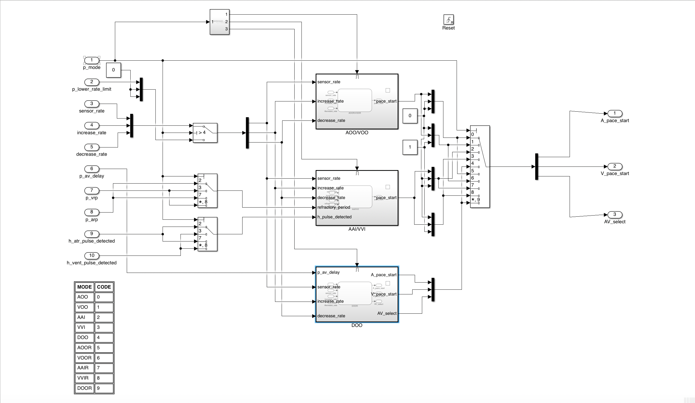

Figure 1: Mode Subsystem

The main logic of the pacemaker is in three Stateflow charts interacting mainly with abstracted variables so as to effectively achieve hardware hiding. There is one Stateflow chart for AOO, VOO, AOOR and VOOR modes, one Stateflow chart for AAI, VVI, AAIR and VVIR modes, and one Stateflow chart for DOO and DOOR modes, of which only one is enabled at one time. The grouped modes are all practically identical in implementation, the only differences being input and output signal routing (which is handled by 4.1.4 Parameter Selection). The sharing of Stateflow charts allows for greater maintainability due to the reduction in code.

In all modes, if the sensor indicated rate is different than the current pacing rate, upon pacing, the current pacing rate is increased or decreased at the appropriate rate given the time spent in the last waiting interval. The rate change is assumed to be linear with time. Since maximum sensor rate is defined to be independently programmable from the upper rate limit, no use was found for the upper rate limit in these modes and was excluded in this design.

That pacing should commence is indicated by a 1 ms pulse on the appropriate out signal. The AV select signal tells the hardware interface which level the next pacing is anticipated to be.

Additionally, to ensure correct behaviour, the mode module is reset upon receiving new parameters.

### AOO/VOO/AOOR/VOOR

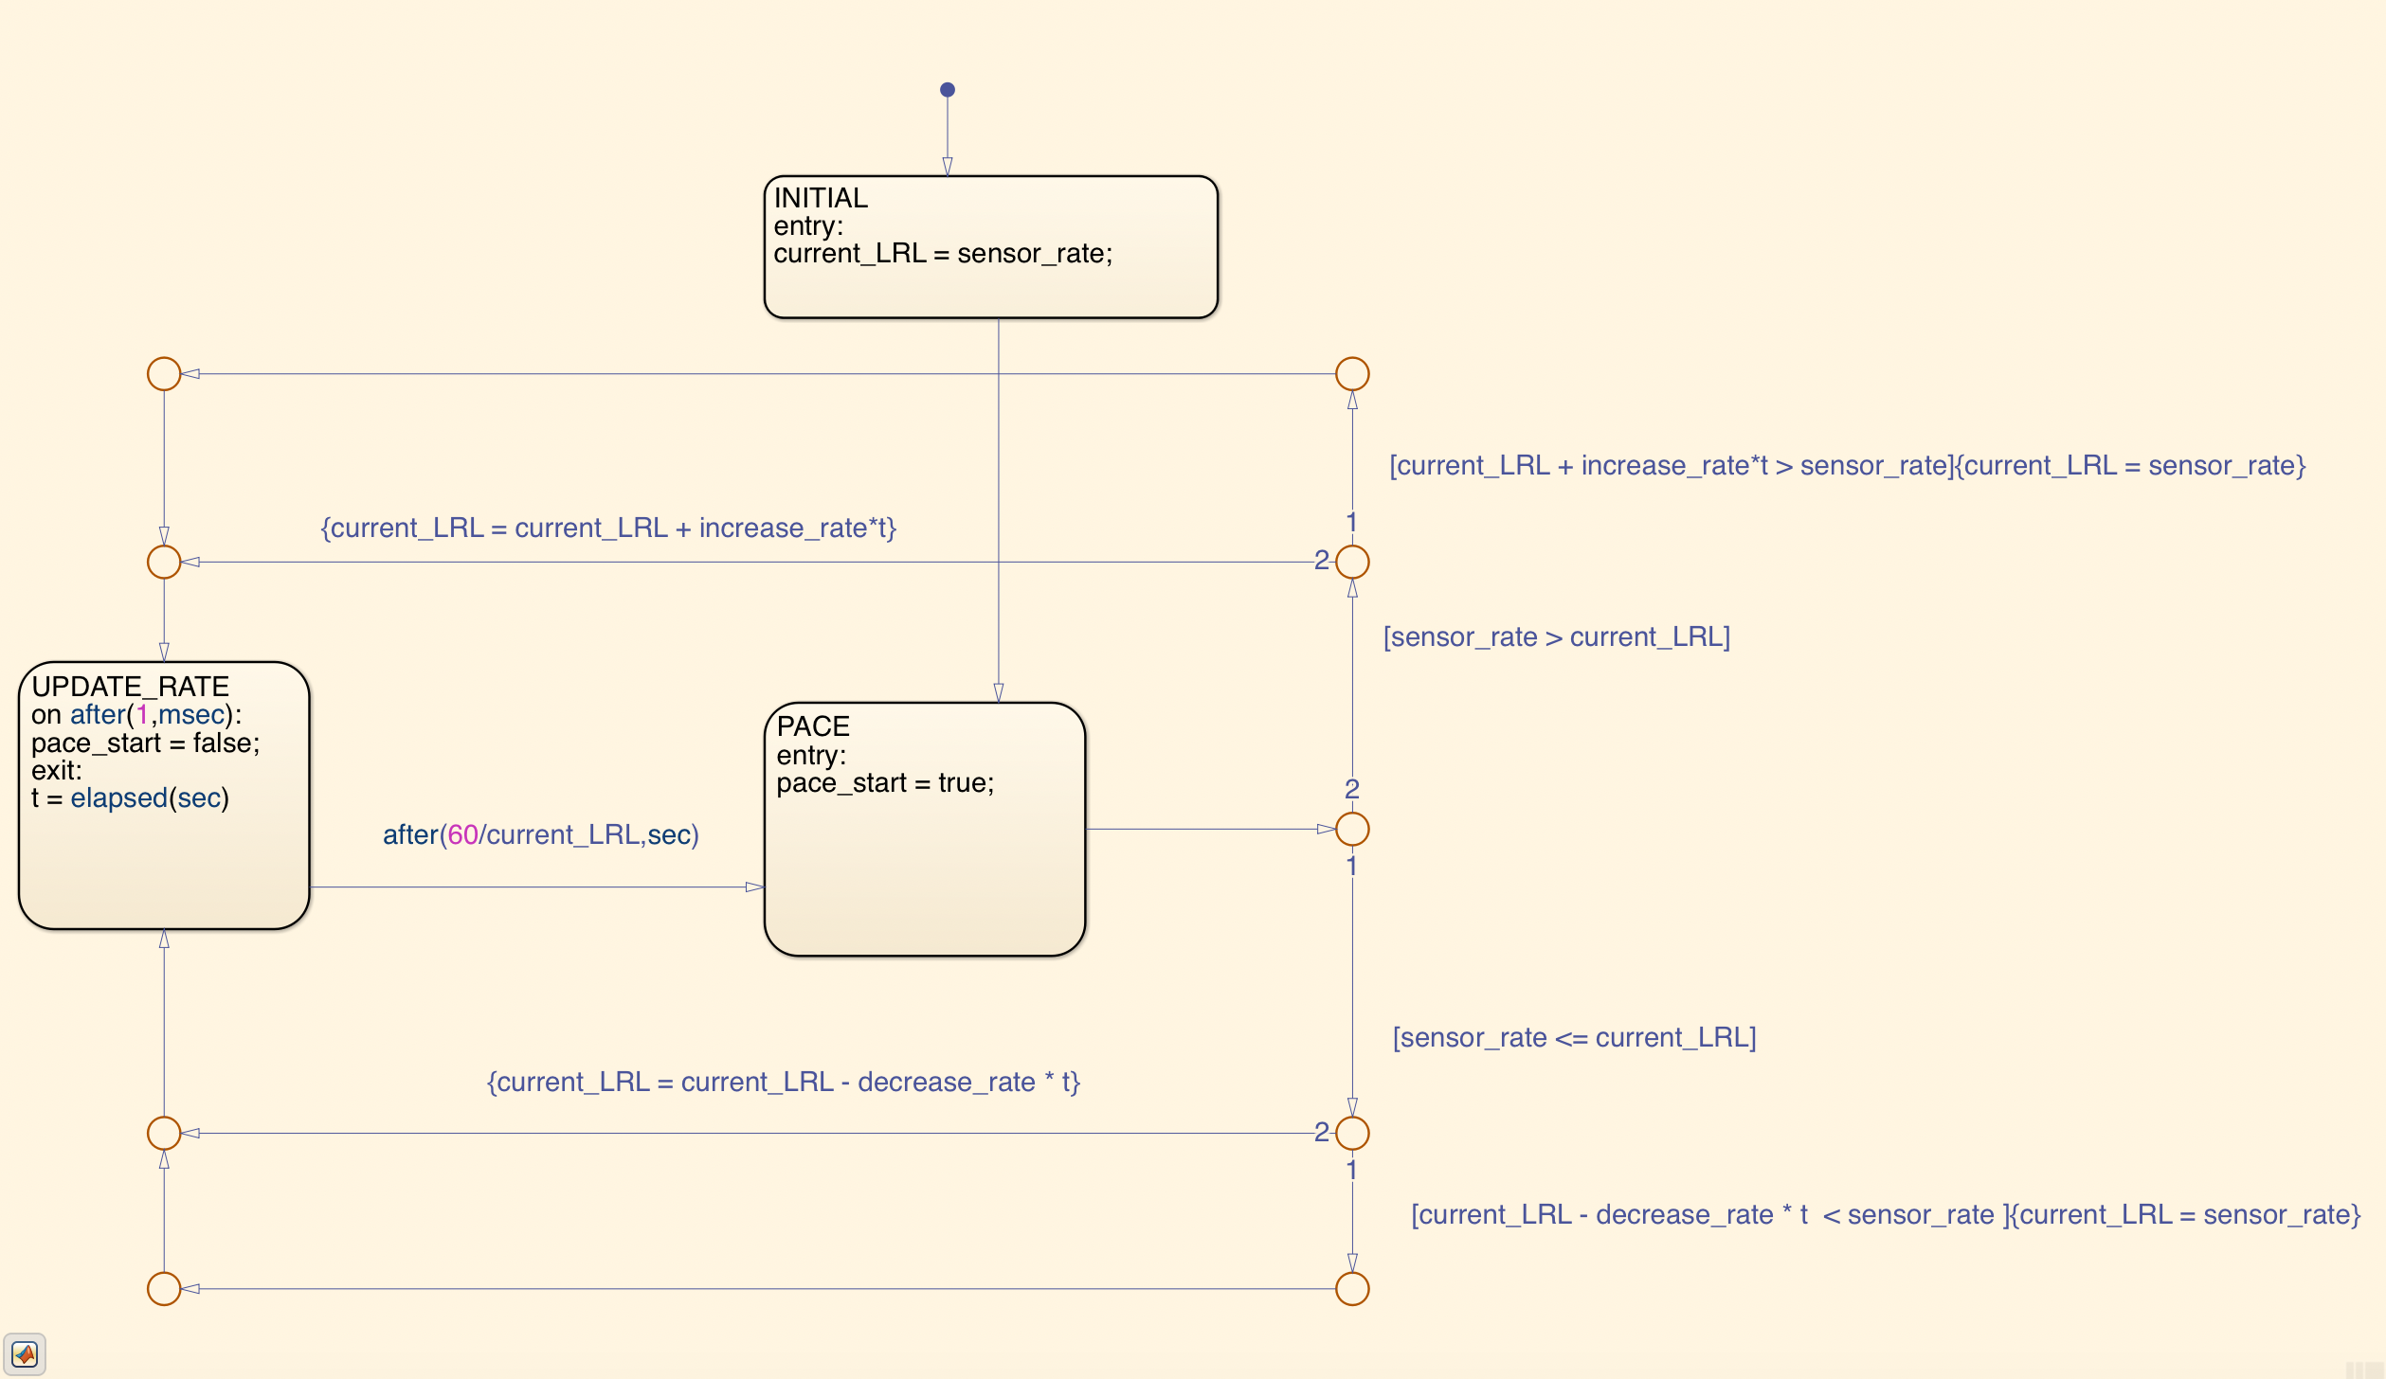

Figure 2: AOO/VOO/AOOR/VOOR Stateflow chart

The AOO, VOO, AOOR and VOOR modes do not require sensing of the heart, and so simply cycle between pacing and waiting states.

### AAI/VVI/AAIR/VVIR

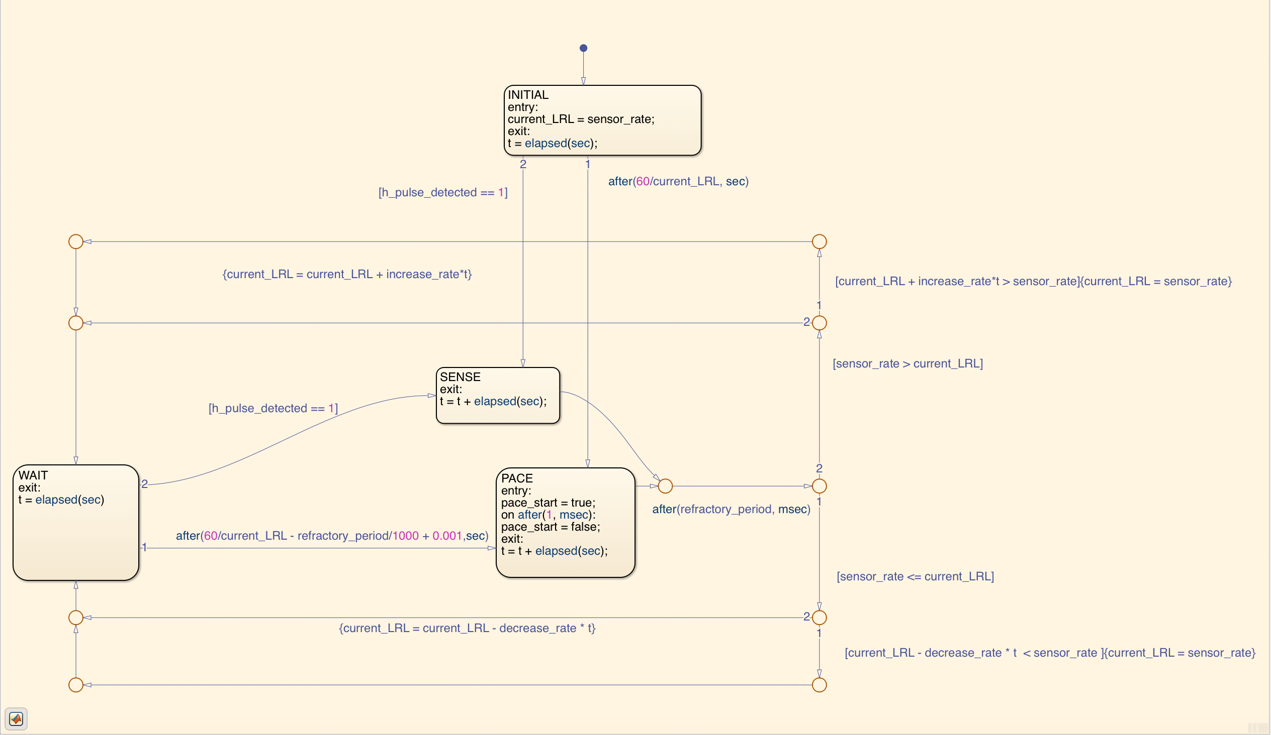

Figure 3: AAI/VVI/AAIR/VVIR Stateflow chart

The AAI, VVI, AAIR and VVIR modes have a similar structure as the XOO modes. Additionally, the pacing state can be bypassed by the sensing of a spontaneous pulse, if said pulse occurs after the refractory period (in which spontaneous pulses have no effect). An additional millisecond is added to the wait interval to ensure that if the heart is spontaneously beating at exactly the current pacing rate, the pacemaker does not pace unnecessarily.

### DOO/DOOR

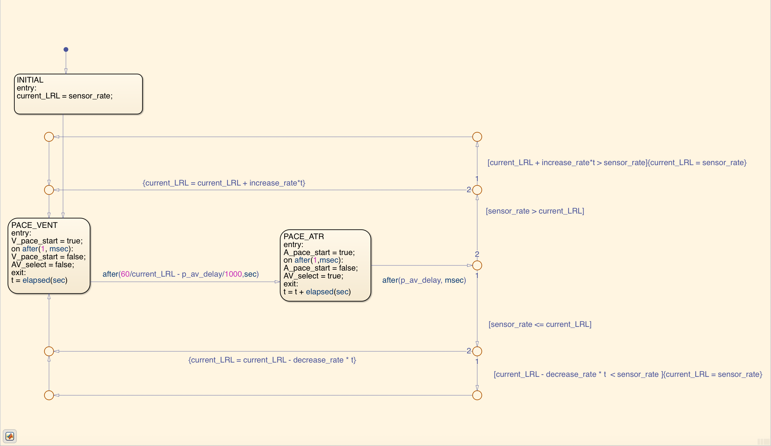

Figure 4: DOO/DOOR Stateflow chart

The DOO and DOOR states are very similar to the XOO states, except that here instead of cycling between pacing and waiting states, atrial and pacing states are cycled. After every atrial pace, AV_select switches to prepare the capacitor charge for a ventricular pace, and vice versa. Additionally, the fixed atrial-ventricular delay is implemented after every atrial pulse.

## Rate Adaptivity

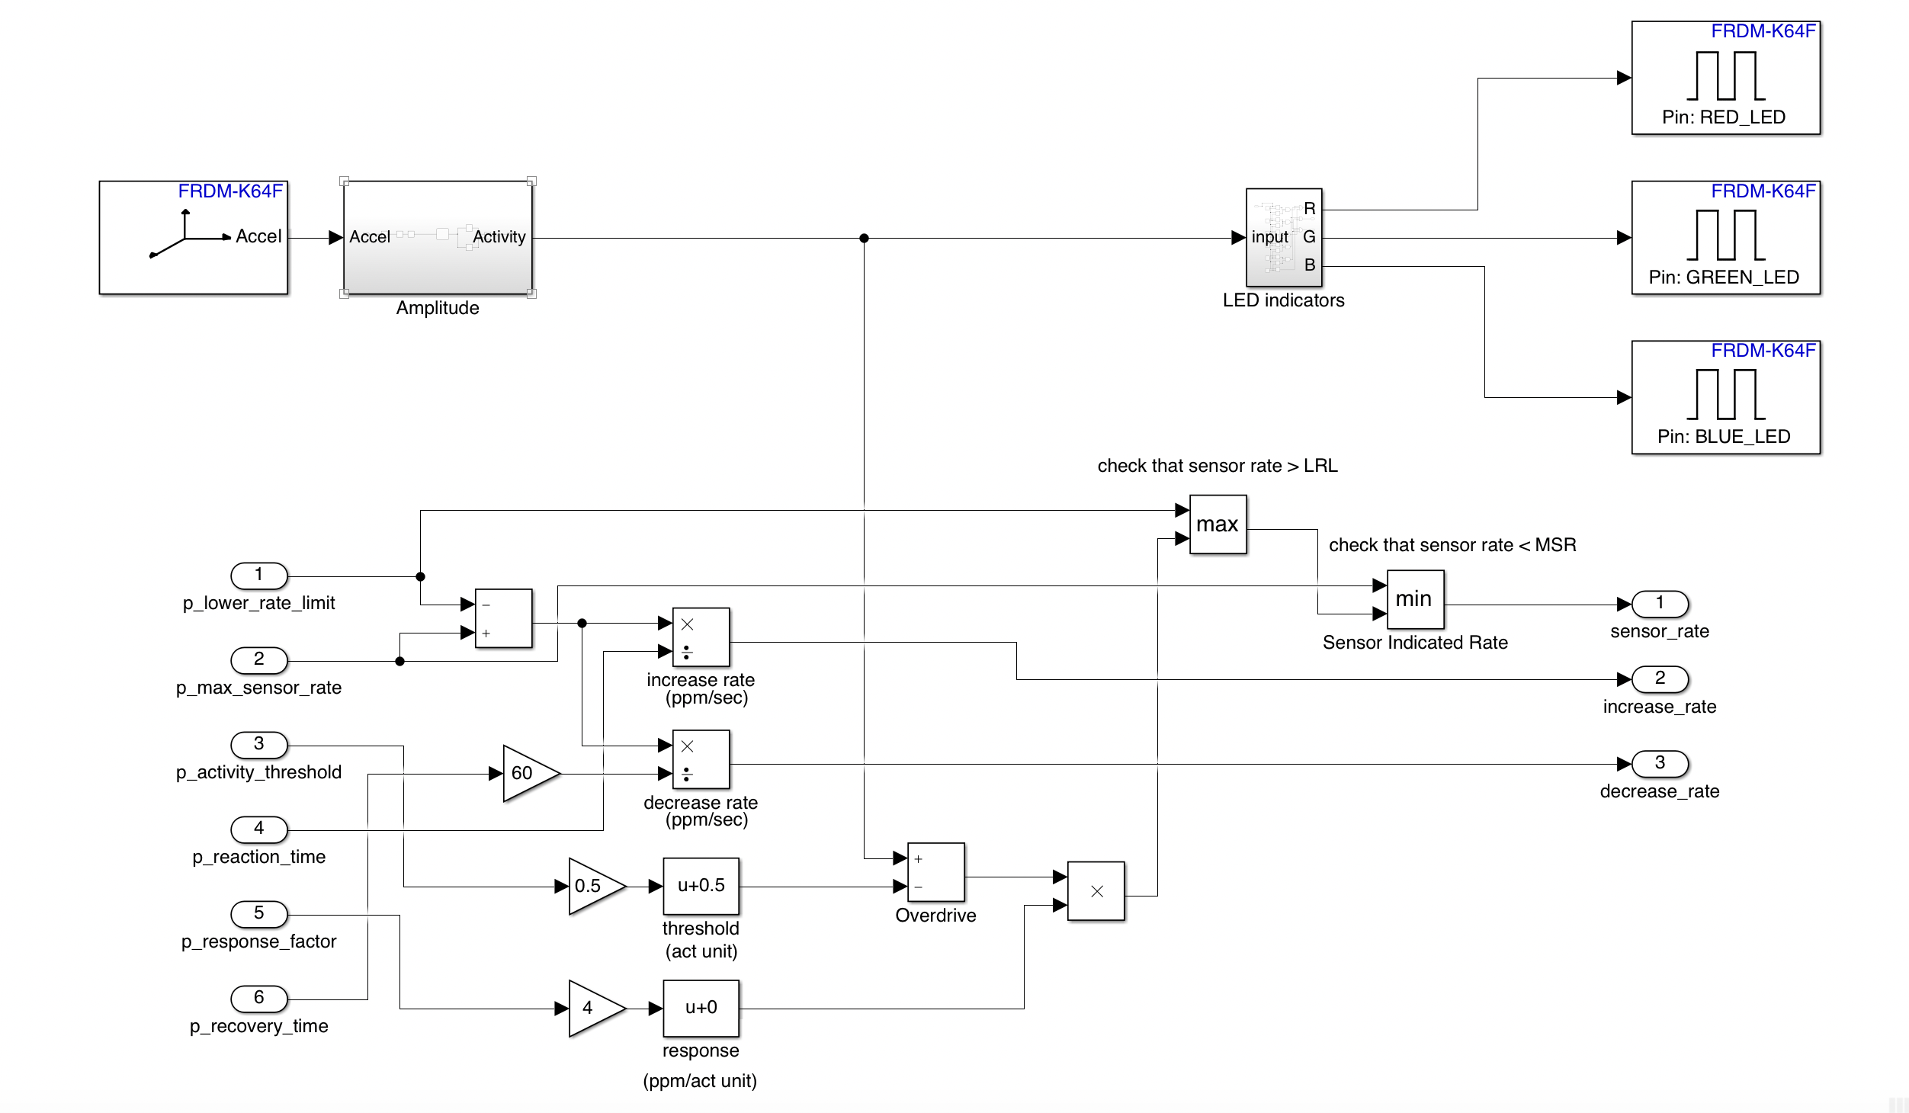

Figure 5: Rate Adaptivity Subsystem

In order to implement rate adaptivity, the activity level is interpreted as the peak-to-peak amplitude of the total accelerometer signal, i.e. $\sqrt{a_{x}^{2}+a_{y}^{2}+a_{z}^{2}}$, where $a_{x}$, $a_{y}$ and $a_{z}$ are the proper accelerations in the local x, y, and z axes respectively. The amplitude is found by sampling the signal from the accelerometer 25 times per second and subtracting the minimum from the maximum of the buffer.

The sensor-indicated rate is assumed to be linearly related to how much the activity level exceeds the activity threshold. By experiment, the activity level can comfortably vary between 0 and 4 units. Thus, the seven activity thresholds were evenly distributed in that range, with V-Low mapped to 0.5 and V-High mapped to 3.5. The response factor multiplied by 4 is then the slope of the response level (in ppm/activity unit) when activity exceeds the threshold. The sensor indicated rate is then checked against the lower rate limit and the maximum sensor rate, and if it falls short of the former or exceeds the latter, it is set to the appropriate value.

The rate of pacing rate increase and decrease is assumed to be linear with time. See 4.2.3 for detailed equations.

## Hardware Interface

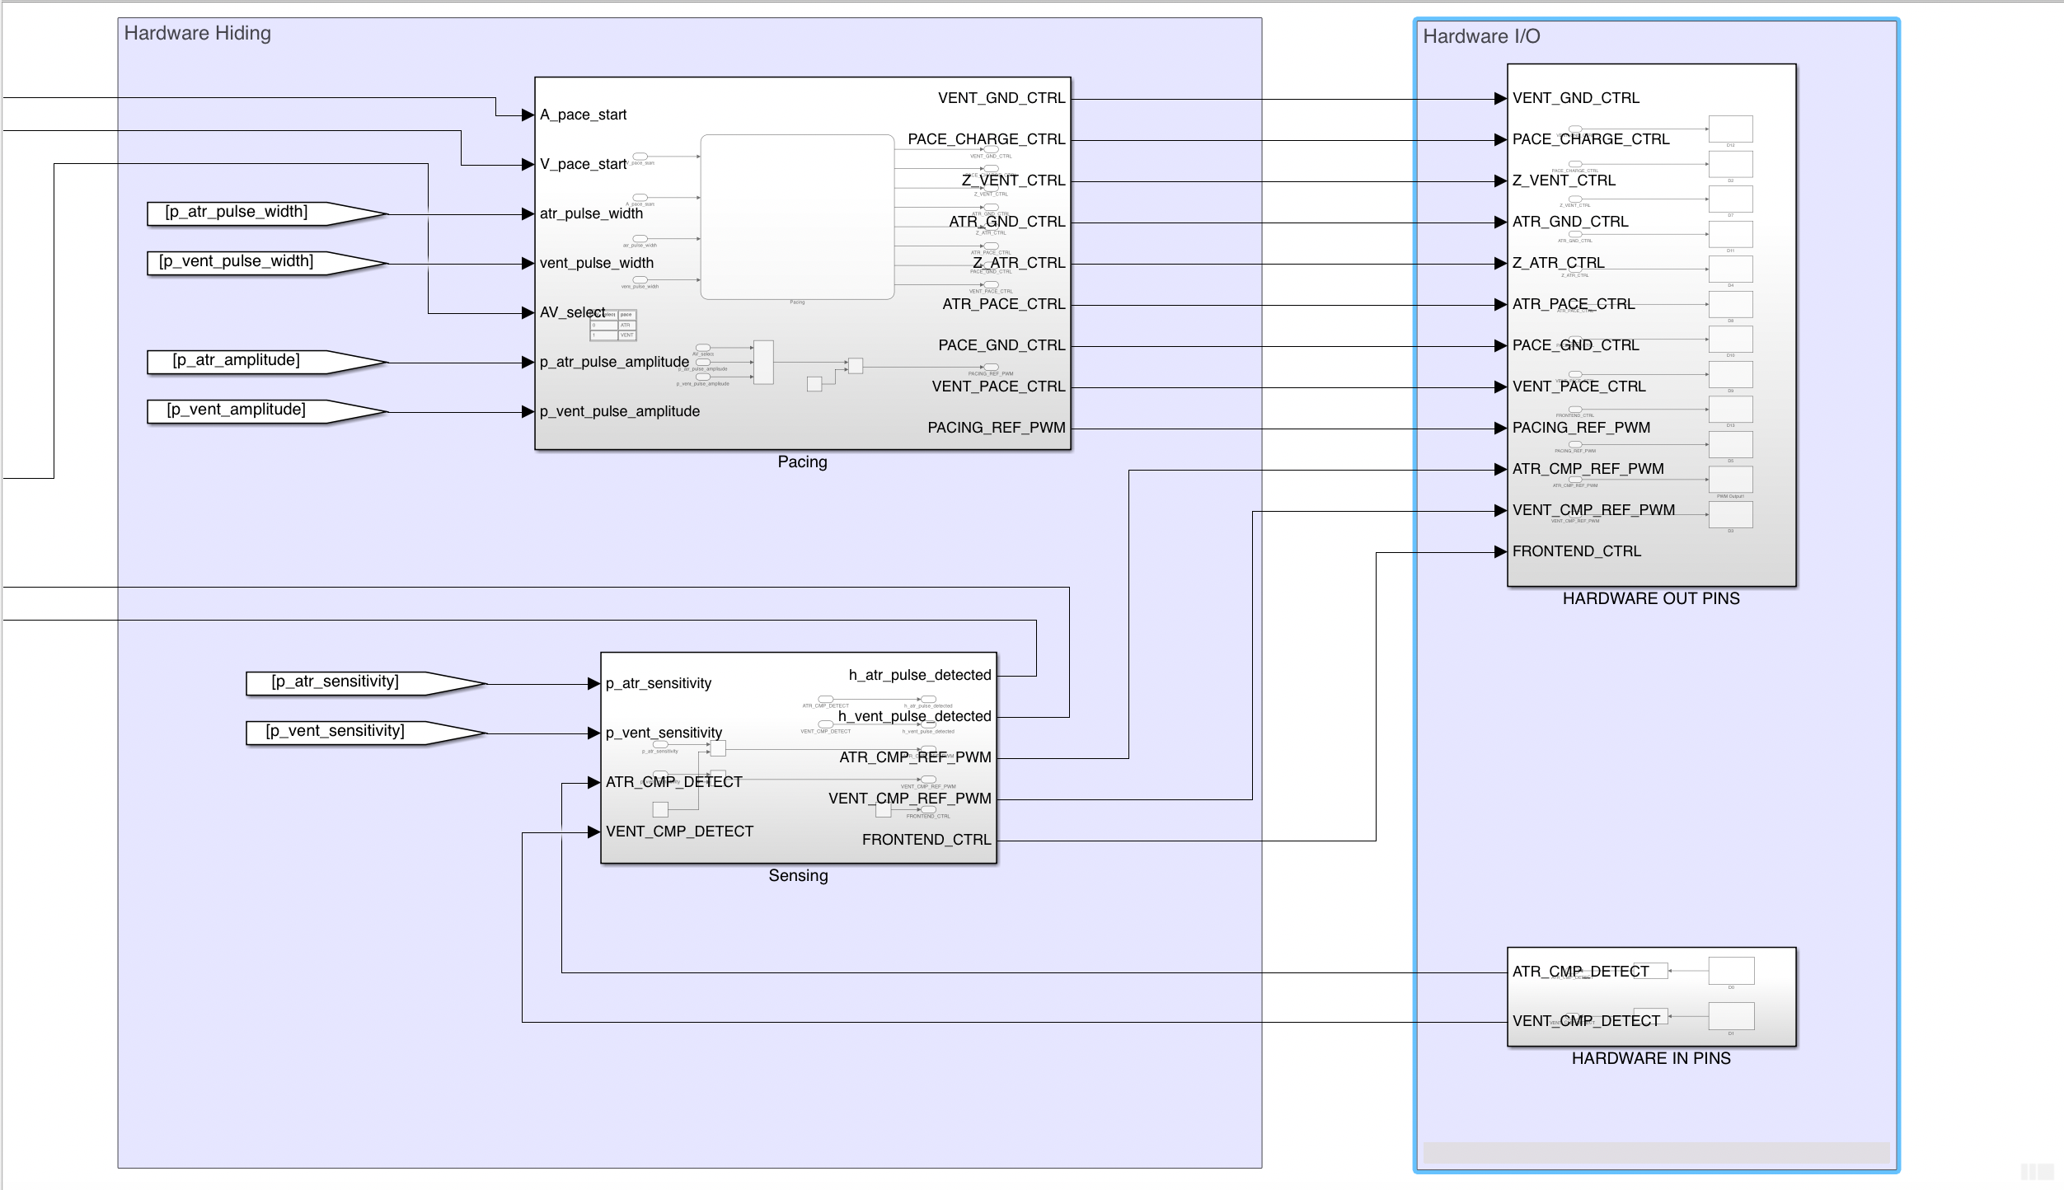

Figure 6: Hardware Interface subsystems

The purpose of the hardware interface is to abstract the IN and OUT variables of the pacemaker so that the main logic of the pacemaker could be easily transferred to any hardware system. This ensures that the only necessary changes would be to the logic detailing how the determined instructions should be best executed on the hardware. The hardware interface need only accept 1 ms pulsed pace atrium/ventricle signals and an atrial-ventricular level selector signal, while outputting 1 ms pulses when atrial/ventricular signals exceed their respective sensitivities.

### Pacing

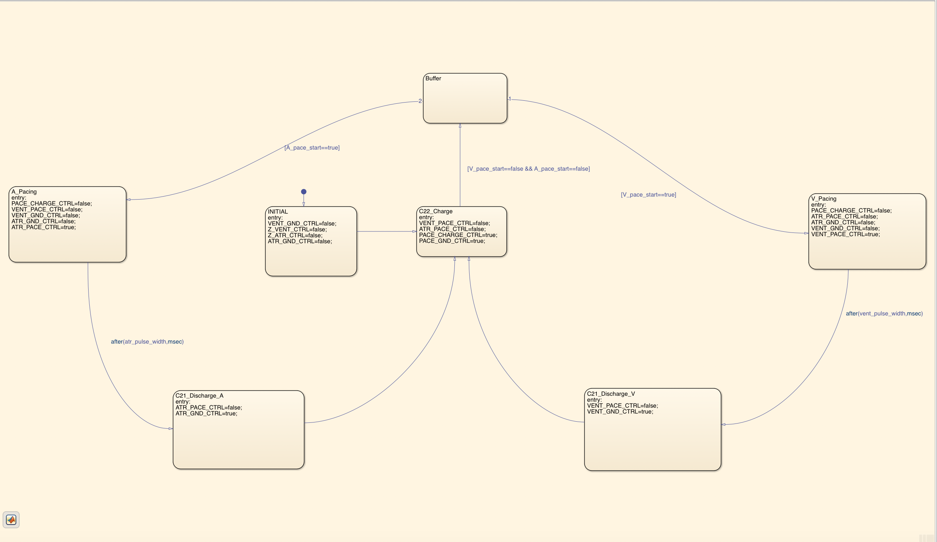

Figure 7: Pacing Stateflow chart

The pacing module waits in a buffer state until a pulse is detected on either the A_pace_start or V_pace_start lines, upon which it sets the appropriate flags to pace the heart. After a delay corresponding to the pulse width, flags are set to begin charging the pacing capacitor again while discharging the blocking capacitor. The buffer state is implemented as a safeguard against looping due to a non-deasserted pacing signal pulse.

### Sensing

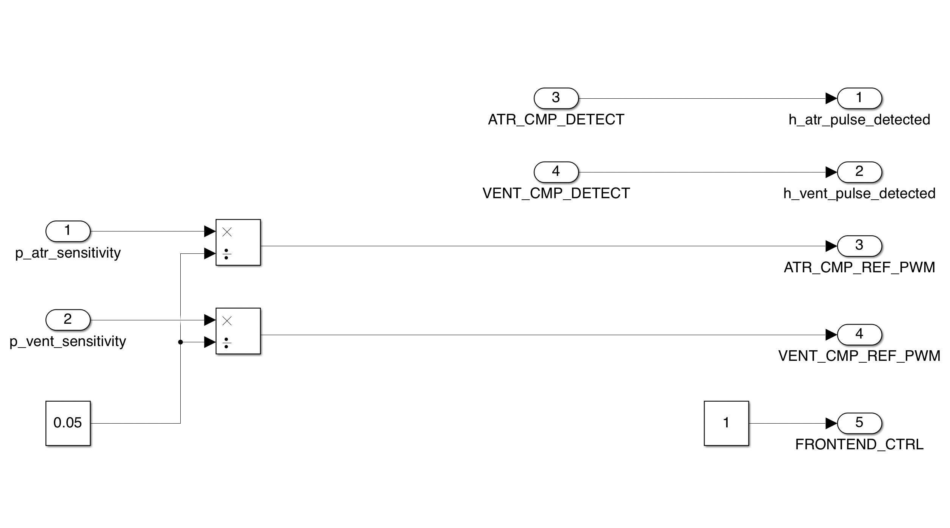

Figure 8: Sensing Subsystem

The sensing module simply sets the appropriate PWMs for the atrial and ventricular reference capacitors, while turning on the FRONTEND_CTRL and routing the natural pulse detection flags to the h_atr_pulse_detected and h_vent_pulse_detected variables.

## DCM Communication

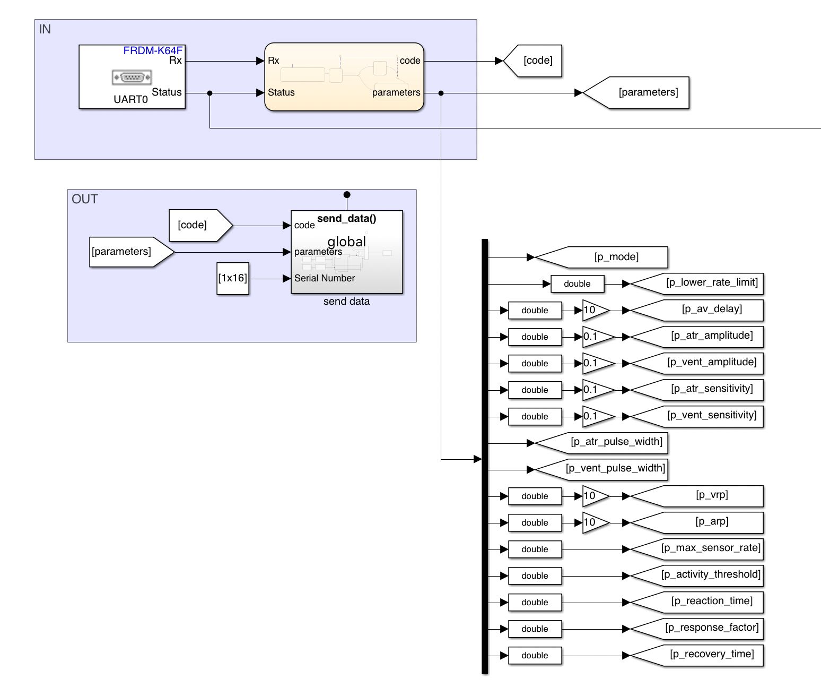

Figure 9: Communications Subsytems

The DCM Communication module handles all external communication. In a similar manner to the hardware interface, it presents abstracted variables to the system while interacting itself with the specific IN and OUT variables. UART communication was chosen for this design.

### In

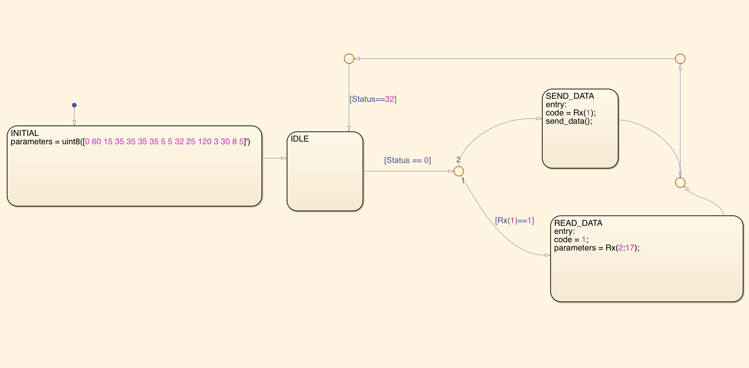

Figure 10: Communications In Stateflow chart

The In module reads the Rx buffer when Status indicates it is full and updates the parameter data or sends data to the DCM depending on the code received.

### Out

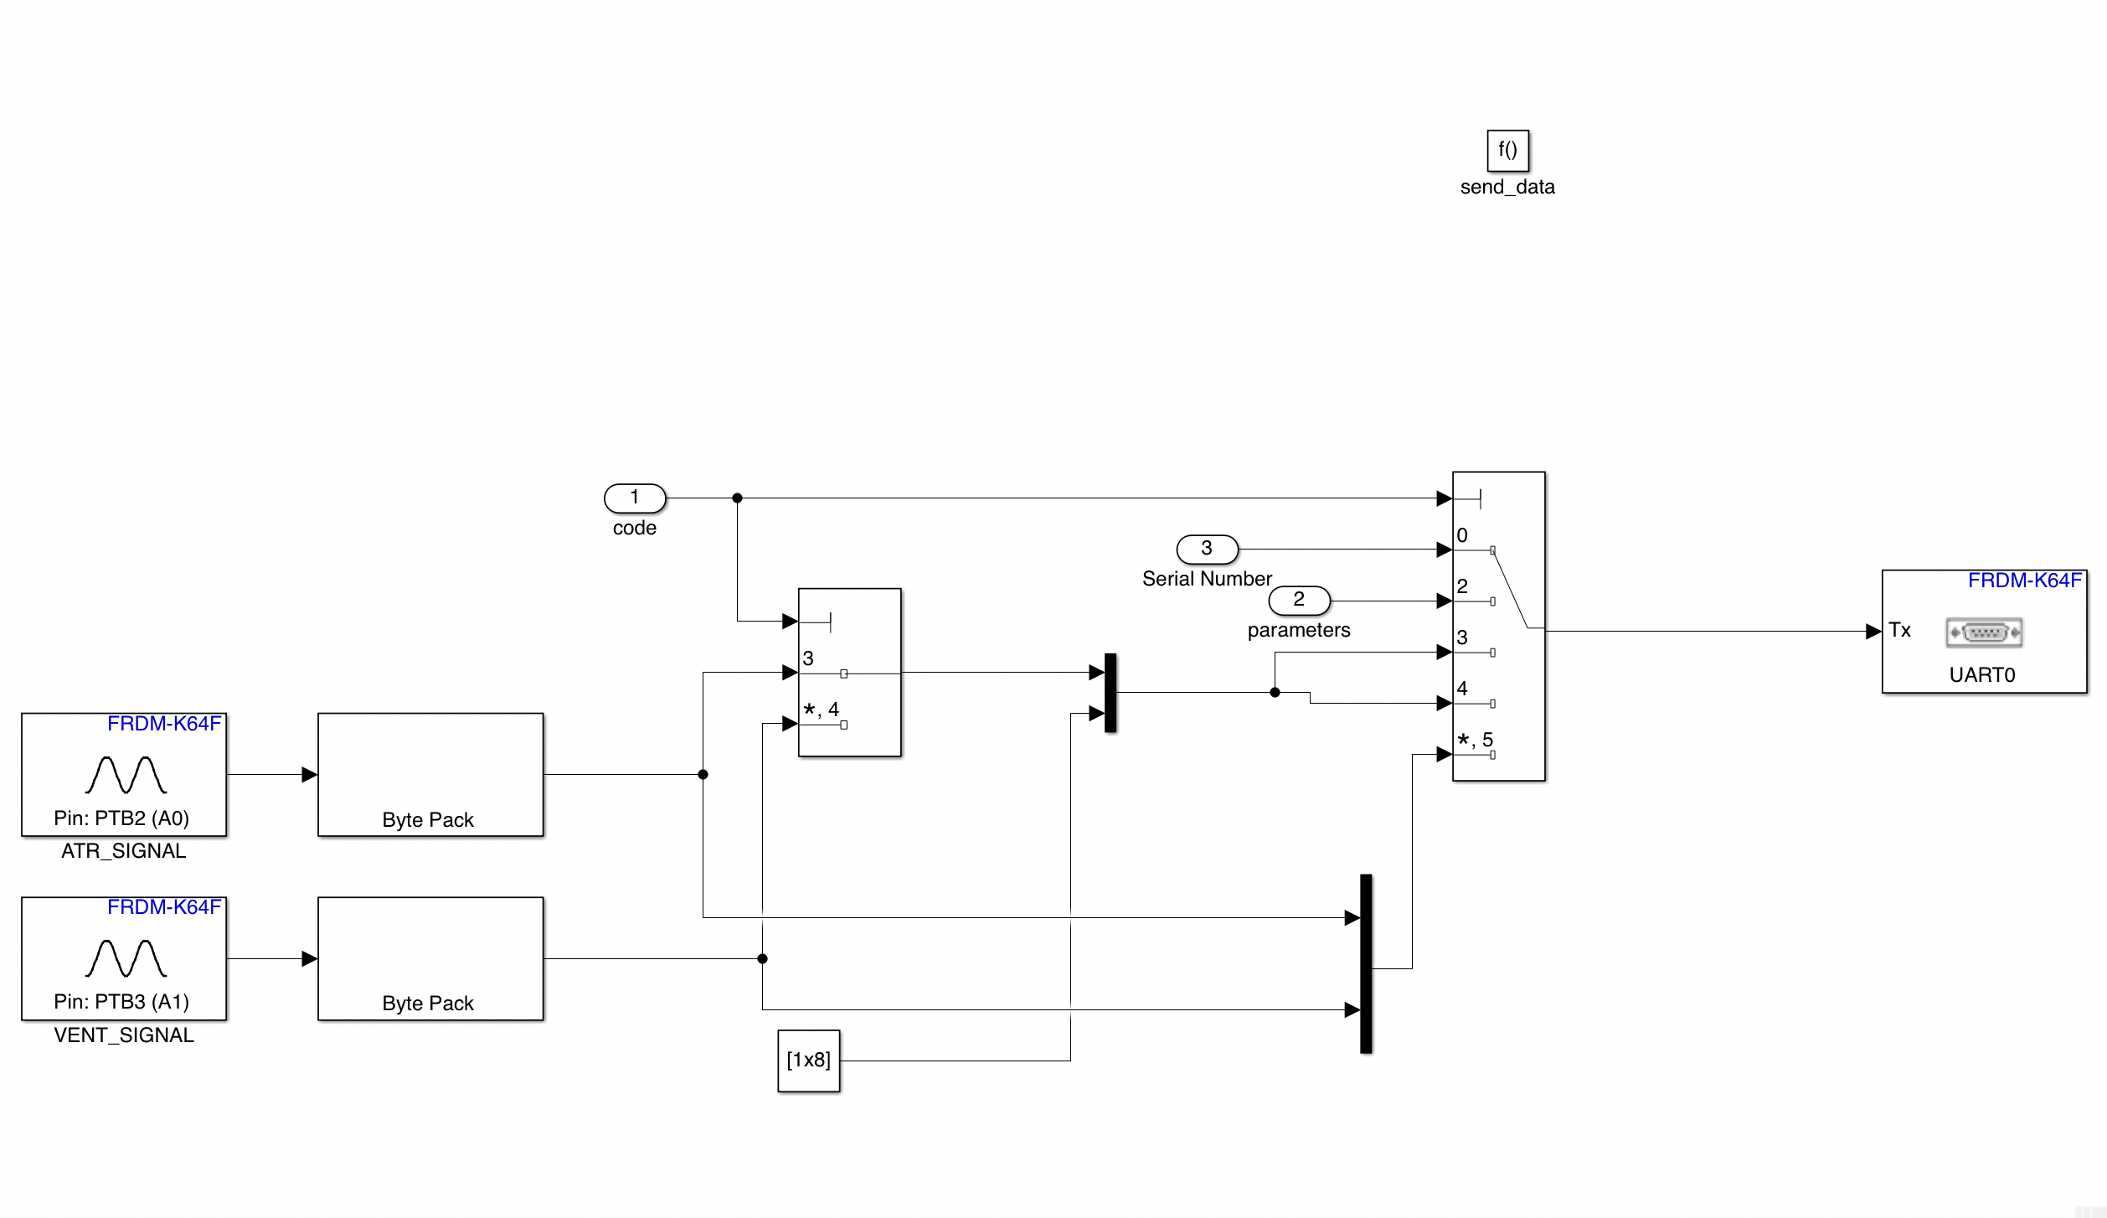

Figure 11: Communications Out Stateflow chart

The out module is only activated when a code of 0, 2, 3, 4 or 5 is received. Data is sent out via UART as detailed in 4.4.2.3.

# Testing

## AOO

Chamber paced: Atrium

Chamber sensed: None

Response to Sensing: None

**Test Cases:**

1. Natural Atrium: **OFF |** Natural Ventricle: **OFF**

In AOO mode, as we are not sensing any chamber, only a single test case (when both atrium and ventricle are not working) can demonstrate correctness of our pacemaker.

*the graph of artificial pulse from HeartView*

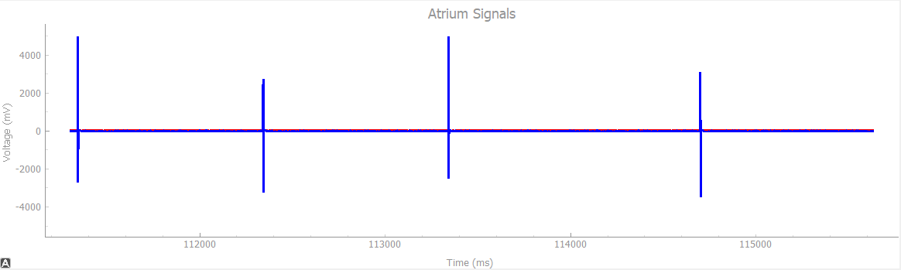

## VOO

Chamber paced: Ventricle

Chamber sensed: None

Response to Sensing: None

**Test Cases:**

1. Natural Atrium: **OFF |** Natural Ventricle: **OFF**

In VOO mode also, as we are not sensing any chamber, only a single test case (when both atrium and ventricle are not working) can demonstrate correctness of our pacemaker.

*The graph of artificial pulse from HeartView*

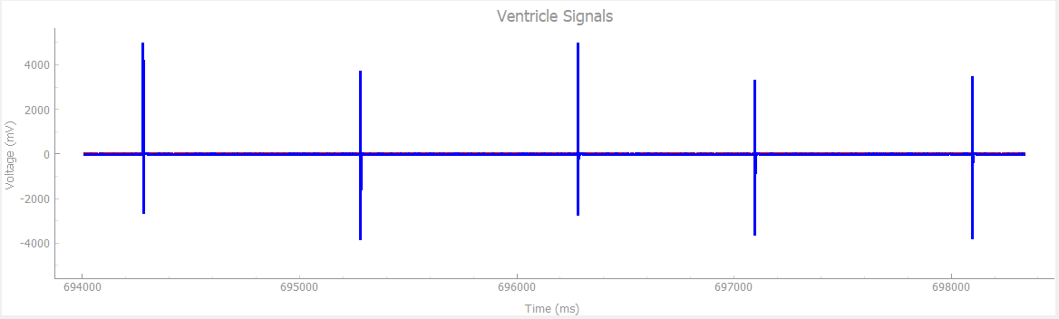

## AAI

Chamber paced: Atrium

Chamber sensed: Atrium

Response to Sensing: Inhibited

**Test Cases:**

1. Natural Atrium: **ON**, Pulse Width: **1ms** |Natural Ventricle: **OFF** | Heart Rate: **30bpm**

At very low Heat Rate and low Pulse Width, pacemaker is supposed to generate pulse (because heart produces pulse every 2000ms, and pacemaker is supposed to maintain Heart rate of 60bpm which is pulse after every 1000ms).

As we can see from the graph below, our pacemaker provides a pulse after every 1000ms to bridge the gap.

*The graph of natural and artificial pulse from HeartView*

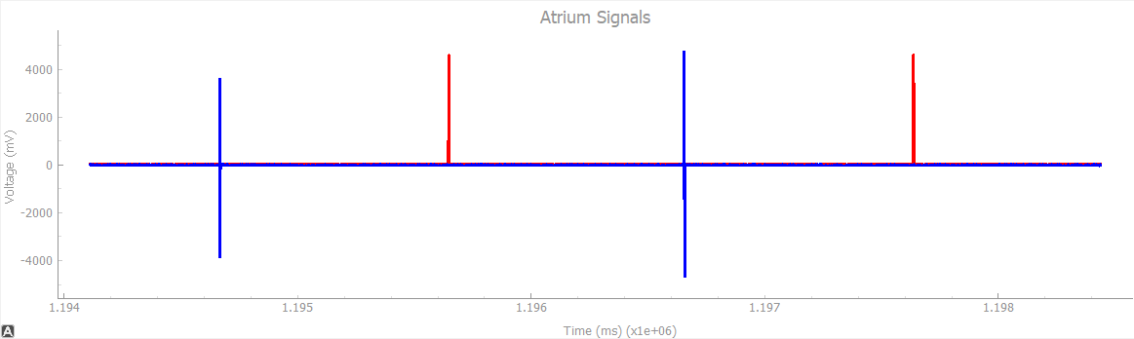

1. Natural Atrium: **ON**, Pulse Width: **10ms** |Natural Ventricle: **OFF** | Heart Rate: **30bpm**

When we increase the pulse width to 10ms and keep hear rate same, still the gap between 2 consecutive pulses is more than 1000ms, so pacemaker is supposed to produce the pulse.

As we can see from the graph below, our pacemaker does the same, it provides the pulse to bridge the time gap.

*The graph of natural and artificial pulse from HeartView*

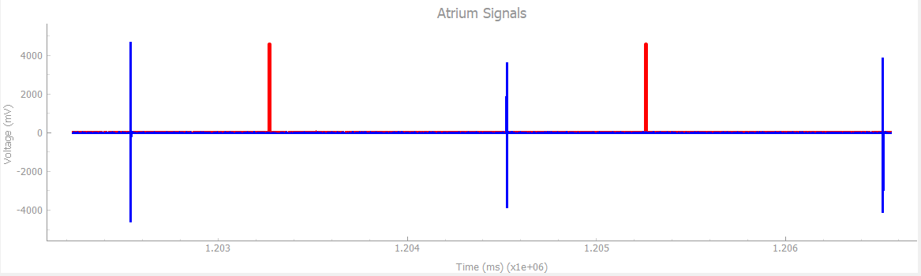

1. Natural Atrium: **ON**, Pulse Width: **1ms** |Natural Ventricle: **OFF** | Heart Rate: **50bpm**

When our heart rate is just below the natural rate but pulse width is not big enough to reach the natural rate (i.e. 60bpm or pulse after every 1000ms), pacemaker is supposed t provide artificial pulse.

From the graph below, it is clear that our pacemaker takes care of the delay.

*The graph of natural and artificial pulse from HeartView*

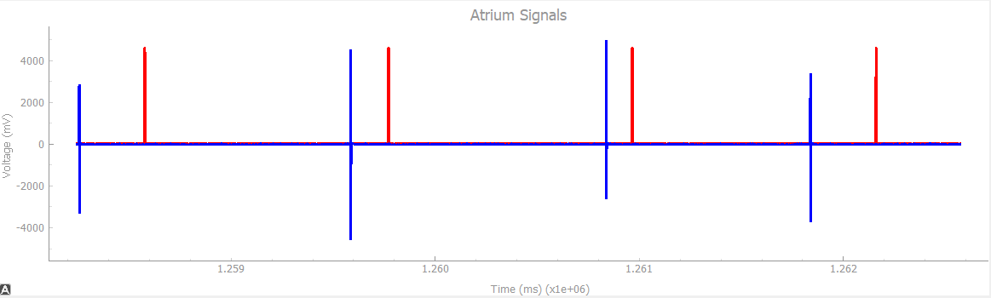

1. Natural Atrium: **ON**, Pulse Width: **10ms** |Natural Ventricle: **OFF** | Heart Rate: **50bpm**

When the heart rate is below normal but pulse width is big enough to account for the gap, pacemaker is not supposed to provide any artificial pulse.

As we can see from the graph below, our pacemaker is not providing any additional pulse to the heart.

*The graph of natural pulse from HeartView*

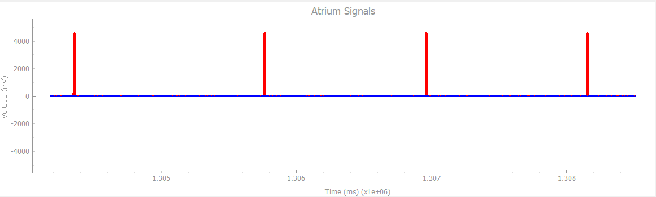

## VVI

Chamber paced: Ventricle

Chamber sensed: Ventricle

Response to Sensing: Inhibited

**Test Cases:**

1. Natural Atrium: **OFF** |Natural Ventricle: **ON**, Pulse Width: **1ms** | Heart Rate: **30bpm**

At very low heart rate, pacemaker is expected to provide pulse at sufficient interval to maintain overall normal heart rate.

As we can see from graph below, our pacemaker provides artificial pulses whenever the time till last pulse is more than 1000ms, which helps in maintaining normal heart rate of 60bpm or pulse after every 1000ms.

*The graph of natural and artificial pulse from HeartView*

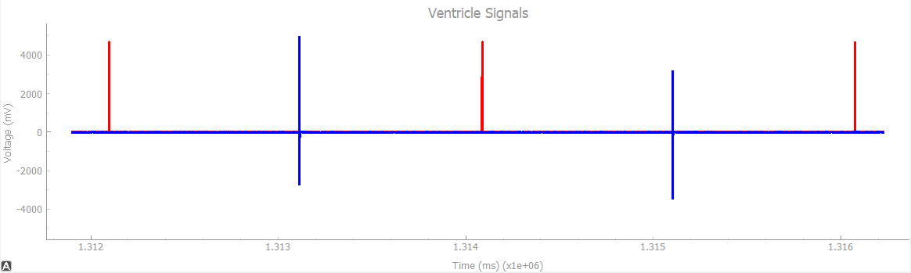

1. Natural Atrium: **OFF** |Natural Ventricle: **ON**, Pulse Width: **10ms** | Heart Rate: **30bpm**

When the heart rate is low, high pulse width is not able to bridge the gap and pacemaker is supposed to provide pulses in order to make sure proper functioning of the heart.

From the graph below, it is clear that our pacemaker sends artificial pulses to the heart and maintains normal functioning.

*The graph of natural and artificial pulse from HeartView*

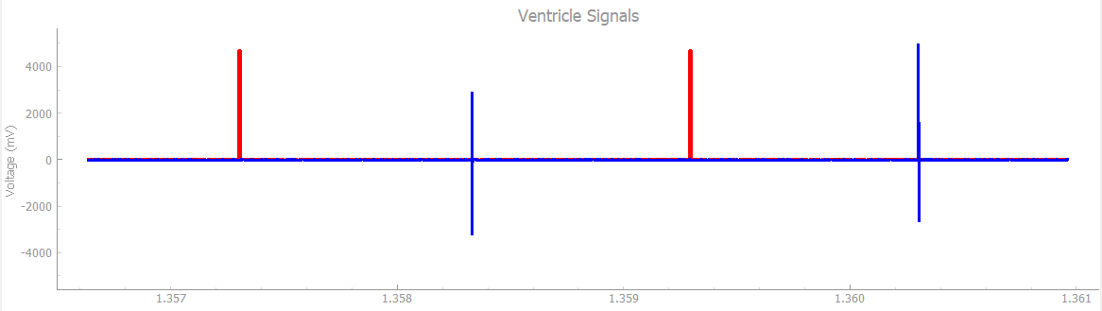

1. Natural Atrium: **OFF** |Natural Ventricle: **ON**, Pulse Width: **1ms** | Heart Rate: **50bpm**

When heart is beating just below normal rate but pulse width is not big enough to bridge the gap, pacemaker is expected to come into play and send pulses to the heart.

From the graph below, we can see that our pacemaker does exactly what is expected.

*The graph of natural and artificial pulse from HeartView*

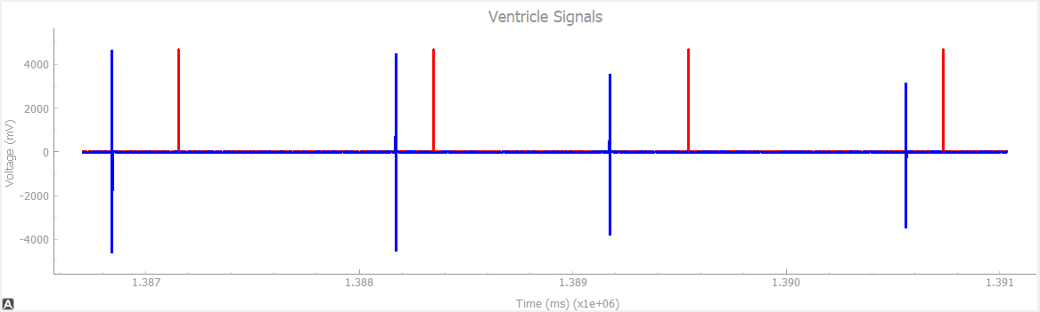

1. Natural Atrium: **OFF** |Natural Ventricle: **ON**, Pulse Width: **10ms** | Heart Rate: **58bpm**

When heart rate is just below the normal and pulse width is wide enough to bridge the gap, pacemaker should not do anything.

As we can see from the graph below, our pacemaker if not producing any artificial pulses to the heart.

*The graph of natural pulse from HeartView*

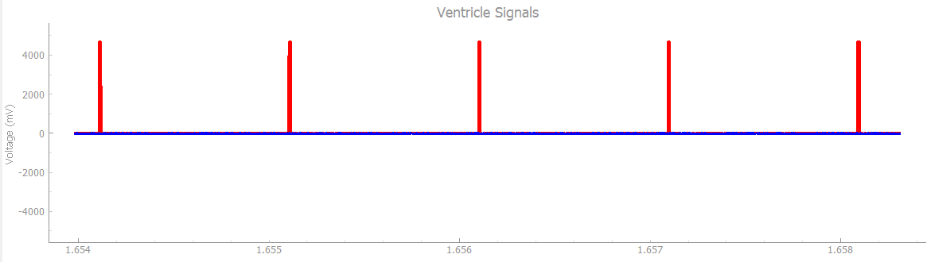

## DOO

Chamber paced: Atrium and Ventricle

Chamber sensed: None

Response to Sensing: None

Rate Modulation

Heartview signals: Natural Atrium: **OFF |** Natural Ventricle: **OFF**

DCM signals:

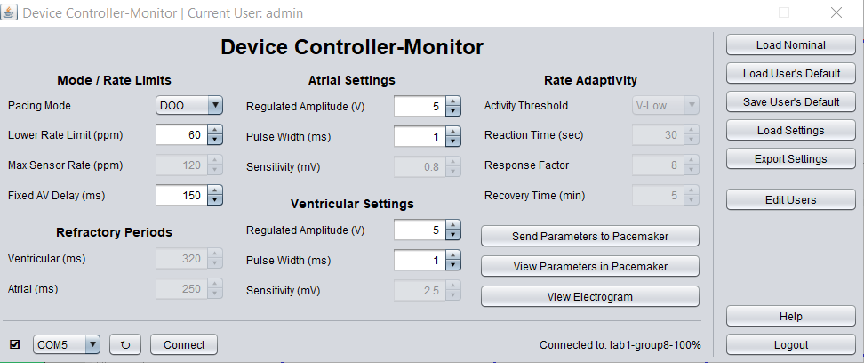

In DOO mode also, as we are not sensing any chamber, only a single test case (when both atrium and ventricle are not working) can demonstrate correctness of our pacemaker.

*The graph of artificial pulse from HeartView*

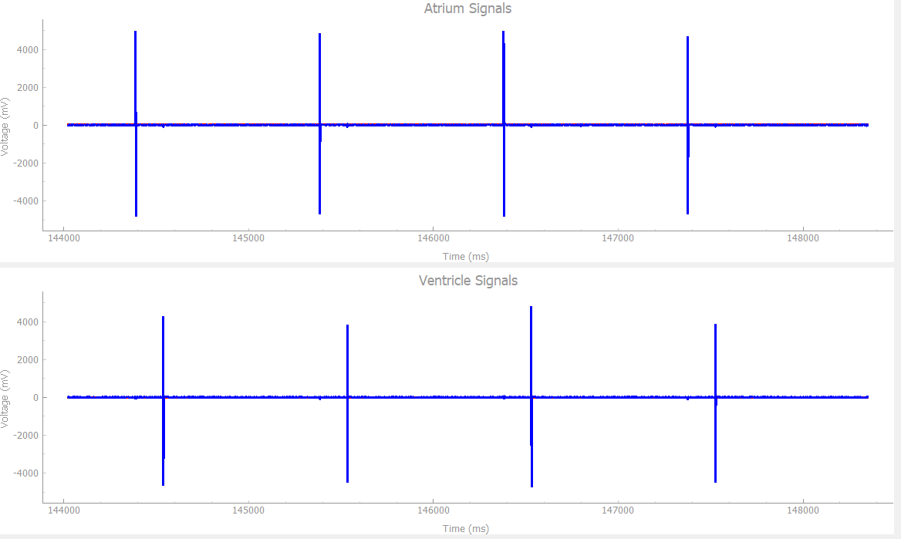

Pace to Ventricle and Atrium with LRL of 60 ppm and an AV delay of 150 ms

**Result**: Passed

## AOOR

Chamber paced: Atrium

Chamber sensed: None

Response to Sensing: None

Rate Modulation

Heartview signals: Natural Atrium: **OFF |** Natural Ventricle: **OFF**

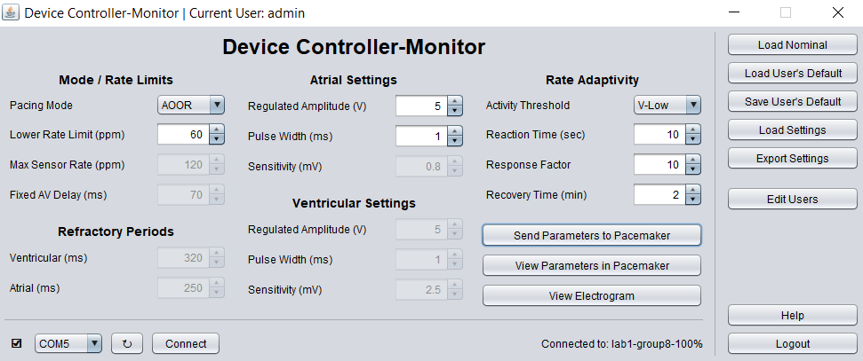

1. **No Activity sensed**

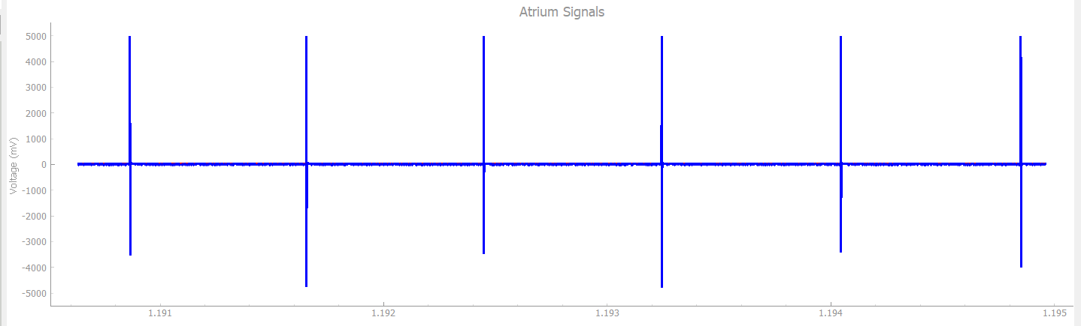

If no Activity is sensed above Threshold, Pace to Atrium with an LRL of 60 ppm

1. **Activity sensed**

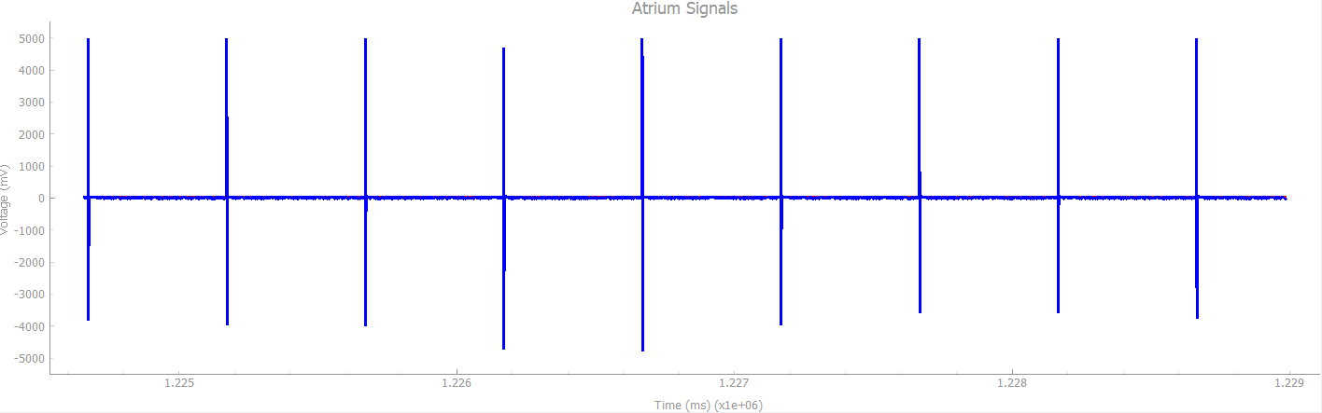

After sensing Activity above Threshold, increase LRL within a response time of 10 seconds and a recovery time of 2 minutes

**Result**: Passed

## VOOR

Chamber paced: Ventricle

Chamber sensed: None

Response to Sensing: None

Rate Modulation

Heartview signals: Natural Atrium: **OFF |** Natural Ventricle: **OFF**

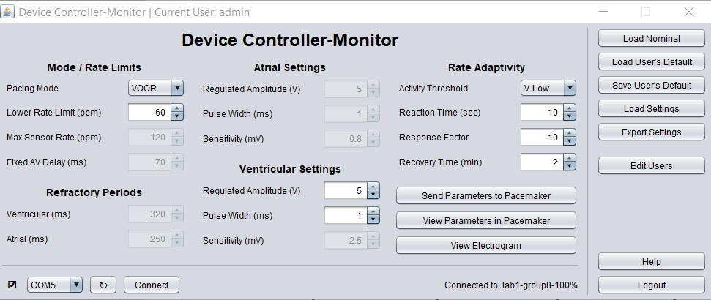

1. **No Activity sensed**

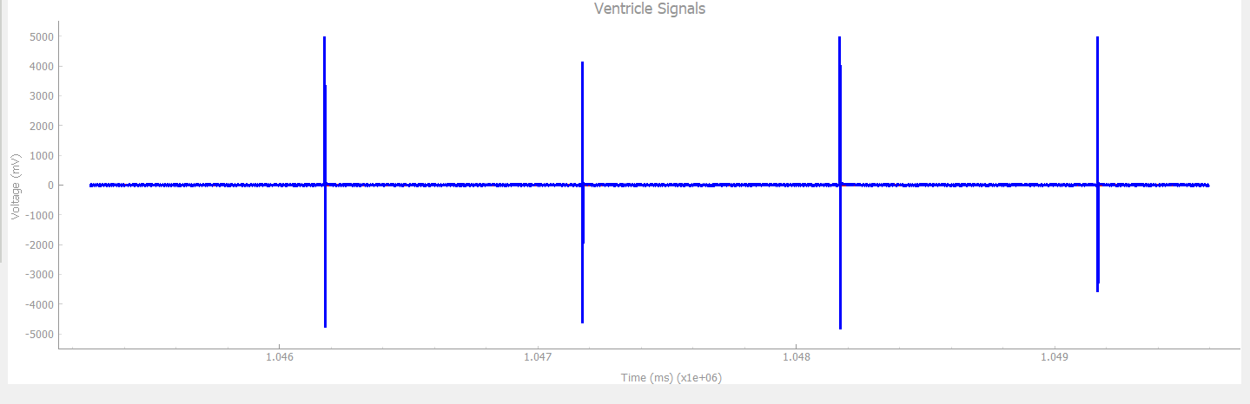

If no Activity is sensed above Threshold, Pace to Ventricle with LRL of 60 ppm

1. **Activity Sensed**

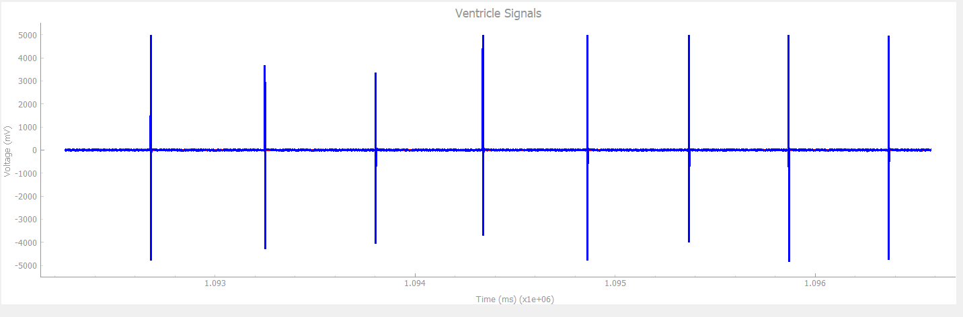

After sensing Activity above Threshold, increase LRL within a response time of 10 seconds and a recovery time of 2 minutes

**Result**: Passed

## DOOR

Chamber paced: Atrium and Ventricle

Chamber sensed: None

Response to Sensing: None

Rate Modulation

Heartview signals: Natural Atrium: **OFF |** Natural Ventricle: **OFF**

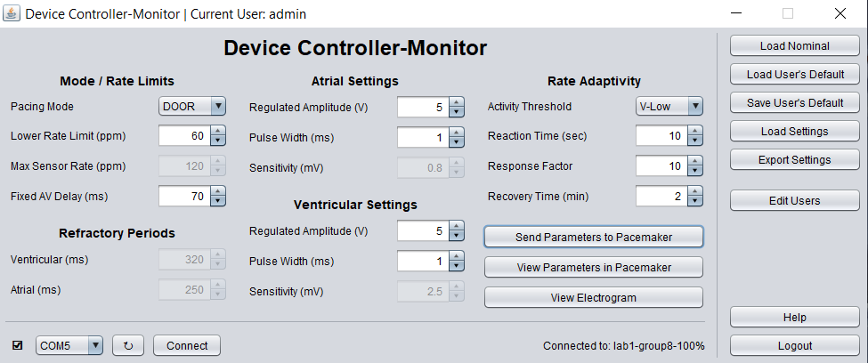.

1. **No Activity sensed**

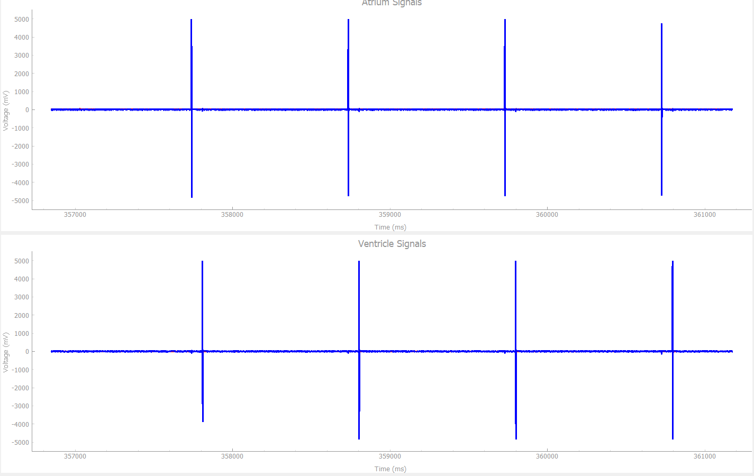

If no Activity is sensed above Threshold, Pace to Ventricle and Atrium with an LRL of 60 ppm and AV delay of 70 ms

1. **Activity sensed**

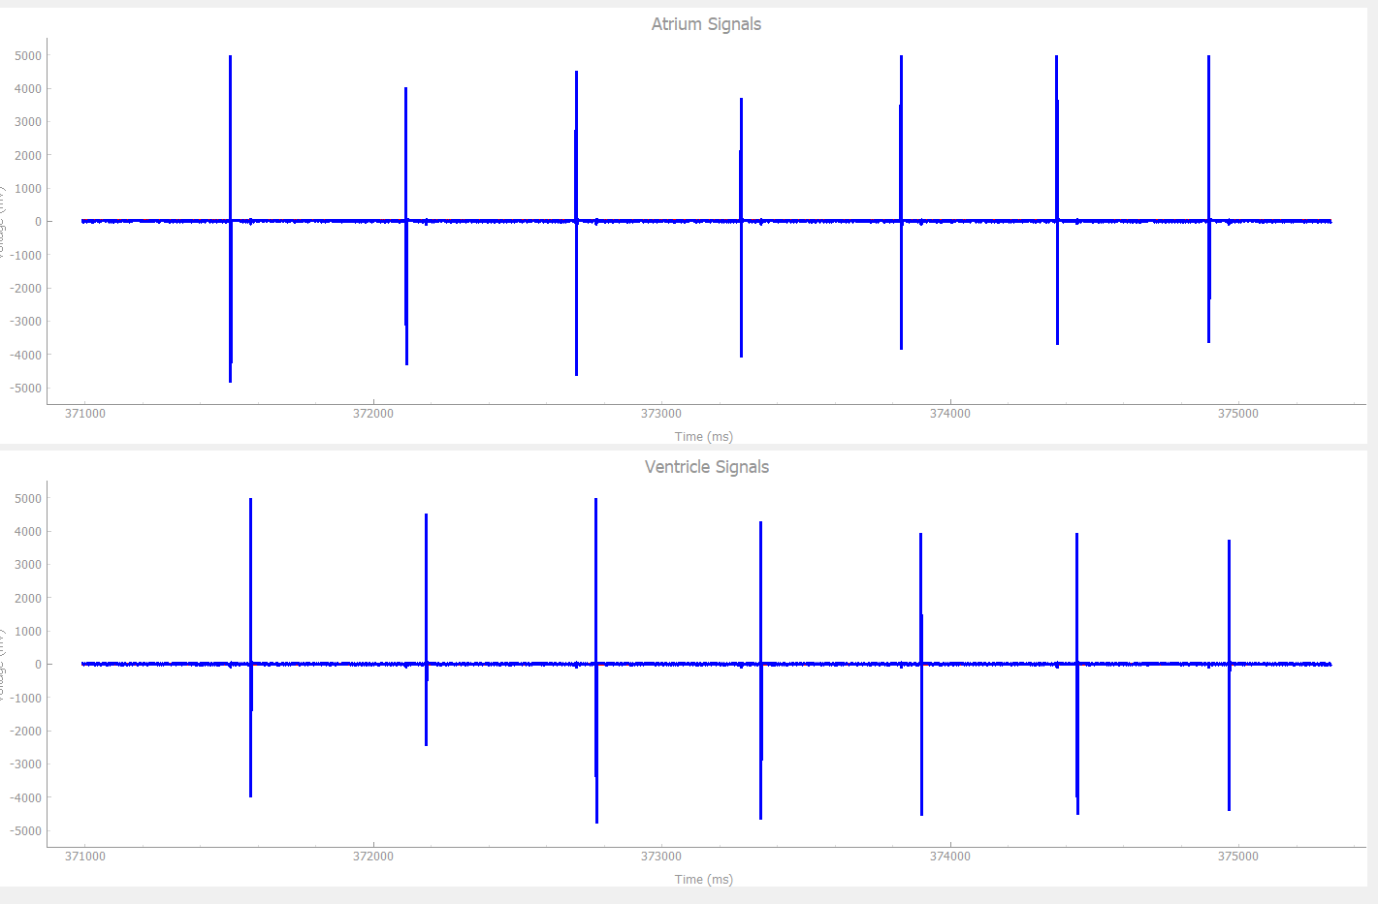

After sensing Activity above Threshold, increase LRL within a response time of 10 seconds and a recovery time of 2 minutes

**Result:** Passed

## AAIR

Chamber paced: Atrium

Chamber sensed: Atrium

Response to Sensing: Inhibited

Rate Modulation

**Test Cases:**

1. **No activity**

Heartview signals: Natural Atrium: **On |** PW: 1ms | Heart rate: 30Bpm

DCM signals:

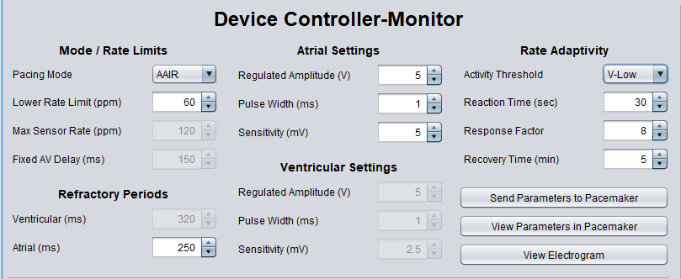

Explanation: When we are operating on AAIR mode with no activity in pacemaker and heart rate is below normal, pacemaker is supposed to produce the pulse to bridge the gap. As we can see from graph below, our pacemaker does the same.

*The graph of artificial and natural pulse from HeartView*

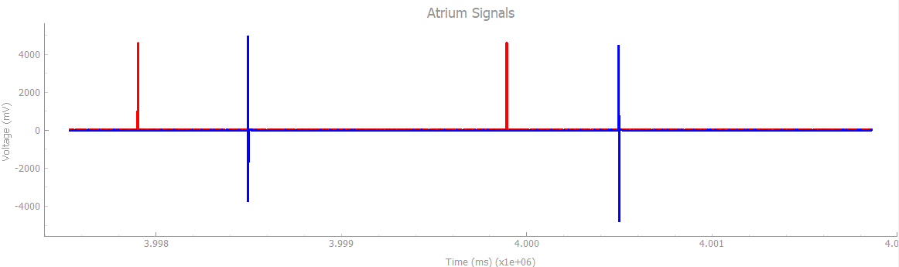

1. **Physical activity**

Heartview signals: Natural Atrium: **On |** PW: 1ms | Heart rate: 30Bpm

DCM signals:



Explanation: When there is some physical activity, our pacemaker produces more pulses than under normal conditions.

*The graph of artificial and natural pulse from HeartView*

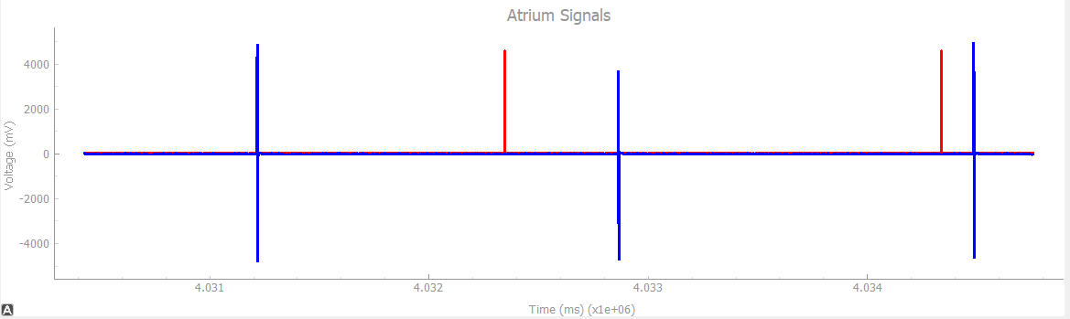

1. **No activity**

Heartview signals: Natural Atrium: **On |** PW: 1ms | Heart rate: 60Bpm

DCM signals:



Explanation: When there is no physical activity and heart is beating at natural rate, pacemaker is not supposed to provide any additional pulse. Our pacemaker does the same which is clear from following graph.

*The graph of artificial and natural pulse from HeartView*

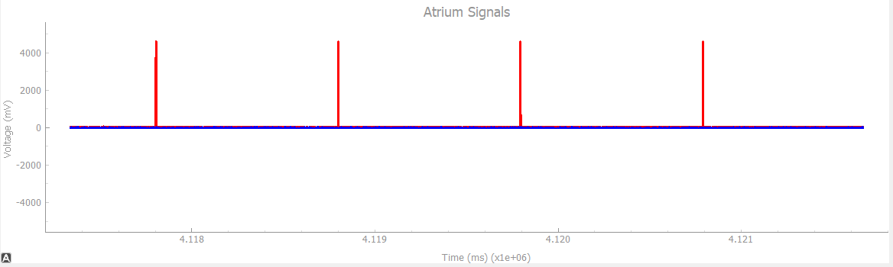

1. **Physical activity**

Heartview signals: Natural Atrium: **On |** PW: 1ms | Heart rate: 60Bpm

DCM signals:



Explanation: When there is some physical activity and heart is beating at regular rate, pacemaker should provide additional pulse to account for the physical activity. It is clear from the below graph that our pacemaker does exactly the same.

*The graph of artificial and natural pulse from HeartView*

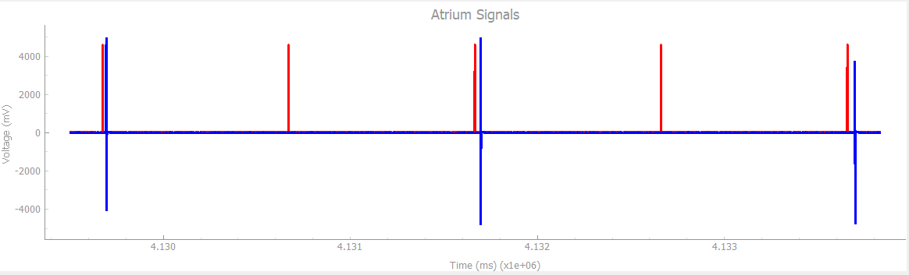

## VVIR

Chamber paced: Ventricle

Chamber sensed: Ventricle

Response to Sensing: Inhibited

Rate Modulation

**Test Cases:**

1. **No activity**

Heartview signals: Natural Ventricle: **On |** PW: 1ms | Heart rate: 30Bpm

DCM signals:

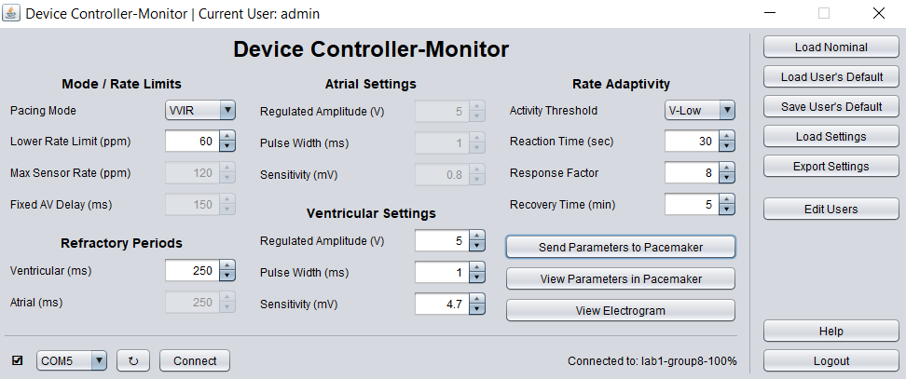

Explanation: When we are operating on VVIR mode with no activity in pacemaker and heart rate is below normal, pacemaker is supposed to produce the pulse to bridge the gap. As we can see from graph below, our pacemaker does the same.

*The graph of artificial and natural pulse from HeartView*

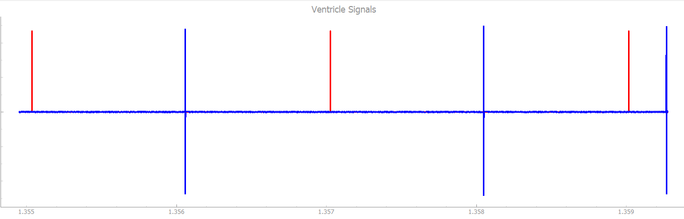

1. **Physical activity**

Heartview signals: Natural Ventricle: **On |** PW: 1ms | Heart rate: 30Bpm

DCM signals:



Explanation: When there is some physical activity, our pacemaker produces more pulses than under normal conditions.

*The graph of artificial and natural pulse from HeartView*

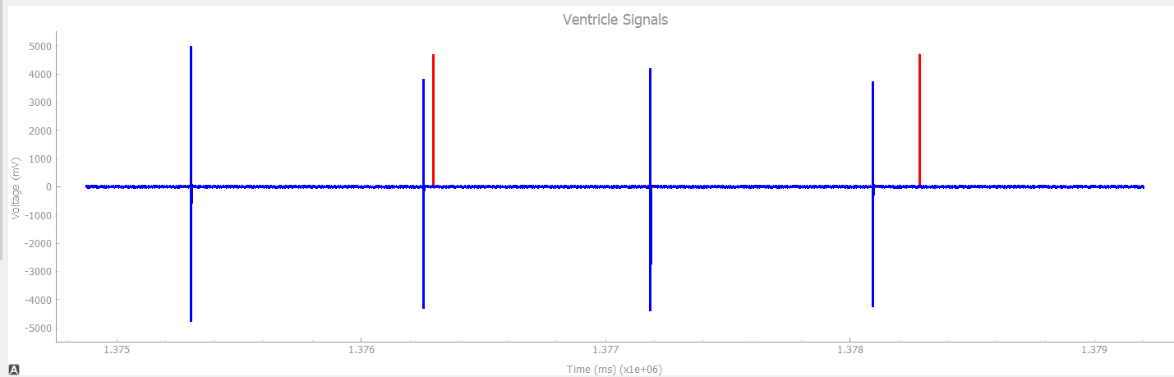

1. **No activity**

Heartview signals: Natural Ventricle: **On |** PW: 1ms | Heart rate: 60Bpm

DCM signals:



Explanation: When there is no physical activity and heart is beating at natural rate, pacemaker is not supposed to provide any additional pulse. Our pacemaker does the same which is clear from following graph.

*The graph of artificial and natural pulse from HeartView*

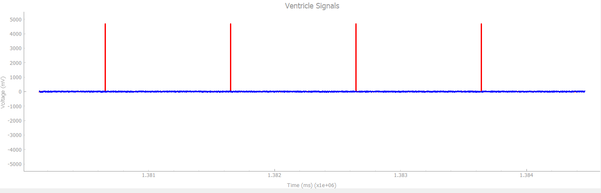

1. **Physical activity**

Heartview signals: Natural Ventricle: **On |** PW: 1ms | Heart rate: 60Bpm

DCM signals:



Explanation: When there is some physical activity and heart is beating at regular rate, pacemaker should provide additional pulse to account for the physical activity. It is clear from the below graph that our pacemaker does exactly the same.

*The graph of artificial and natural pulse from HeartView*

